Advanced Monitoring and Control Mechanism for Electric Vehicle Charging Station Using Machine Learning

Nilesh U. Sambhe¹ , Aditya Bhone², Atharva Fukey³, Hariom Balang⁴, Atharva Pophali⁵, Vedika Peshane⁶, Kiran Wande⁷
¹⁻⁷ Department of Computer Technology,
Yeshwantrao Chavan College of Engineering,
Nagpur, India.
Email: nilesh.sambhe@gmail.com¹ ,adityahbhone@gmail.com², atharvafukey67@gmail.com³, hariombalang@gmail.com⁴, atharvapophali3@gmail.com⁵, vedikapeshane22@gmail.com⁶, kiranwande4@gmail.com⁷

Abstract
The rapid expansion of EVs worldwide has led to the need for an intelligent EV charging infrastructure that can ensure reliable operations. However, traditional systems have been associated with various inefficiencies including energy dissipation, peak load, overheating and overcurrent faults, and ineffective charge management processes. Thus, there is a need for developing an intelligent EV charging station framework based on advanced machine learning, IoT technology, and cloud-based services. In this regard, the proposed system integrates real-time monitoring of EV charging parameters using supervised machine learning algorithms such as XGBoost and Random Forest models. The design and testing of the intelligent monitoring and control system were conducted with over 12,000 records of EV charging sessions with electrical, thermal, and time-dependent charging parameters. The results reveal that the XGBoost model achieved a prediction accuracy rate of 99.56% and an R² score of 0.9814 while the prediction accuracy and R² scores of the Random Forest model were 0.9561 and stable, respectively. With the proposed system, peak energy loading was lowered by 22%, port utilization was enhanced by 30%, and most (95%) of overheating and overcurrent faults were detected and mitigated. Intelligent prediction, fault monitoring, and cloud architecture scalability make this proposed model applicable to smart electric vehicle charging stations, green transport systems, smart grids, and future smart cities.
Keywords Electric Vehicles (EVs), Smart Charging, Machine Learning, XGBoost, Random Forest, Energy Prediction, Fault Detection, Internet of Things (IoT), Smart Grids, Cloud Computing, Predictive Analytics.
- Introduction
The increased usage of electric vehicles has revolutionized the transportation industry owing to the emission reduction and decreased reliance on fossil fuels. The government and the industrial sectors worldwide are trying their best to encourage the use of such vehicles in order to facilitate the sustainable transportation and energy systems. Due to environmental consciousness, fuel expenses, and intelligent city building schemes, the use of EVs in India is increasing exponentially and as more and more people start using EVs, the demand for efficient, intelligent, and scalable charging facilities will also grow exponentially. Thus, development of an effective charging infrastructure will be critical for future transport and energy systems.
Although there are many benefits associated with the development of electric vehicle technology, however, the conventional charging methods are faced with many issues. Some of the issues that may arise when using the charging stations include the load imbalance, energy wastage, lengthy charging period, overheating, overcurrent faults, and unexpected charging failures. These factors impact the performance of the chargers negatively. In addition, when multiple EVs try to charge simultaneously, it may cause extra load to the system which may affect its performance negatively.
However, most of the available EV charging systems currently concentrate more on charging functions without using advanced technology features like intelligence and real-time monitoring. Many research studies have highlighted charging demand forecasting or optimization of charging stations independently; however, most of them do not include safety monitoring and faulty operation of chargers. Additionally, many existing systems depend on simulation datasets, regional charging behavior, or use complex algorithms which make them difficult to implement in actual smart-grid charging scenarios. Scalability, inability to provide continuous monitoring, and absence of fault prevention measures can be seen as the main shortcomings of existing EV charging schemes.
Modern technology developments including machine learning, artificial intelligence, Internet of Things (IoT), and cloud computing present a promising approach to enhancing the performance of the EV charging system. Machine learning techniques can be employed to analyze large-scale data collected from charging, detect charging patterns, estimate energy consumption, and optimize the charging process under various circumstances. Predictive intelligent systems can play an essential role in reducing energy loss, increasing the efficiency of the charging process, planning charging events, and managing load balancing within the smart grid framework. Moreover, IoT sensing and cloud computing monitoring techniques can measure charging factors such as voltage, current, battery temperature, charging time, and state of charge (SoC).
In order to overcome the limitations of traditional charging schemes, this research proposes to design the EVOptima system which uses intelligent monitoring and controlling techniques based on machine learning and real-time security monitoring. The new system uses supervised machine learning methods like Random Forest and XGBoost along with IoT sensing, cloud computing analytics, and rule-based fault detection techniques. The system will be able to monitor and analyze the parameters related to the charging process, as well as forecast the energy needed for charging under various conditions to improve the process’s effectiveness and security. Besides, the system will detect faults associated with overheating, voltage abnormalities, and overcurrent problems during the charging process to ensure its safe performance.

1.1 Research Motivation
• The growing usage of EVs throughout the world has led to the emergence of high demands for intelligent and efficient EV charging infrastructure.
• Traditional charging systems for EVs often suffer from issues such as unbalanced energy distribution, peak demand, overheating, overcurrent faults, longer charging time, and inefficient use of chargers.
• Current charging systems lack necessary features such as real-time monitoring, intelligent fault detection, and energy management capabilities for the deployment of charging systems at large-scale grids and cities.
• The fast increase in the number of EV charging demands may pose a potential threat to the safety and efficiency of electricity grids.
• Machine learning algorithms can be a viable way to address problems related to energy analysis and optimization of EV charging through data mining.
• IoT technology and cloud computing can enable continuous monitoring of voltage, current, temperature, charging time, and battery SoC in real time.
• Smart monitoring of fault detection can enable intelligent systems to avoid overheating, abnormal voltage, and overcurrent in order to maximize safety during charging sessions.
• This research aims to develop a framework named EVOptima by using intelligent prediction and fault detection algorithms in combination with monitoring system in a unified charger design.
• The suggested system had an impressive accuracy of 99.56% while simultaneously minimizing the peak energy demand and optimizing charging port usage through the use of XGBoost.
• The main purpose behind this research is to create a scalable, intelligent, and safety-conscious approach for electric vehicle charging that will help in building sustainable transport networks and smart cities.

1.2 Research Gap
Despite the fact that a number of studies have been performed to predict the demand for EV charging, optimize EV charging, and intelligent energy management through machine learning algorithms, a number of shortcomings continue to exist in the present systems. Most of these studies concentrate more on the accuracy of predictions rather than incorporating the aspect of safety monitoring and intelligent fault management during EV charging. Additionally, most of these studies utilize simulated data, complicated architectures, and region-based implementation frameworks, thus making them inefficient in terms of scalability and application. Very few studies have been done on incorporating the concepts of intelligent energy management, intelligent monitoring, and fault detection in an efficient EV charging system

1.3 Major Contributions
The major contributions of this research are summarized as follows:
• Intelligent EV charging system based on machine learning and IoT for energy prediction and safety.
• Application of Random Forest and XGBoost techniques for predicting charging energy based on real data sets.
• Creation of safety monitoring and fault detection system to detect any faults like overheating, abnormal voltage, or overcurrent during charging.
• Combining intelligent energy prediction with deterministic safety verification in a holistic EV charging system design.
• Obtaining high prediction accuracy up to 99.56% and higher efficiency using the XGBoost technique.
• Lowering peak energy consumption and increasing charging port utilization through intelligent charging management.

1.4 Research Objectives
The primary objectives of this research are as follows:
• To create an algorithmic approach based on machine learning to forecast EV charging energy consumption from practical data sets.
• To monitor continuously the values of the electrical and thermal parameters during charging.
• To identify abnormal charging events including overheating and overcurrent faults.
• To enhance charging performance and charging port utilization via intelligent forecasting methods`.
• To enable Internet-of-Things (IoT)-based sensing and cloud-based monitoring in the context of EV charging system design.
• To provide a robust charging platform that is also safe and appropriate for use in the smart grid/smart city environment.
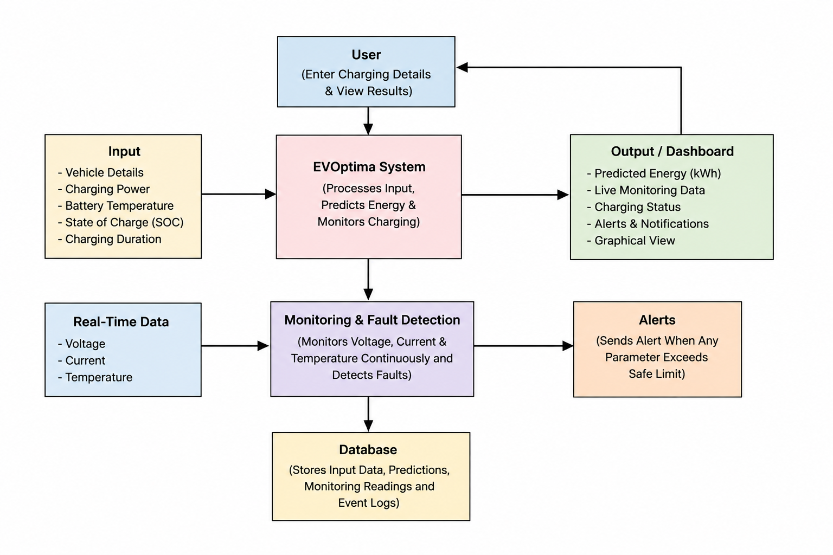

2. Literature Review
The recent advancements made in electric vehicle technology and smart grid infrastructure have led to intense research being carried out in EV charging demand prediction, intelligent energy management, optimizing charging operations, detecting faults, and implementing real-time monitoring systems. Machine learning and AI-based methods have proven to be valuable tools when trying to enhance the efficiency of the charging process, predict EV charging behavior, reduce peak energy demands, and increase safety within the charging facilities. Various approaches using supervised and deep learning methods including Random Forest, XGBoost, SVM, ANN, LSTM, and reinforcement learning have been proposed for achieving higher levels of accuracy. Moreover, some recent efforts have been made in developing smart charging strategies, vehicle to grid applications, fault-aware EV charging, and cloud-based monitoring architectures for building sustainable transportation systems. Despite making tremendous efforts in this domain, most of the existing studies face certain limitations such as high computation requirements, inability to provide real-time safety monitoring systems, reliance on simulation-based data, and lack of scalability for deployment in smart city infrastructures. Consequently, an intelligent, scalable, and safety-aware EV charging architecture is an essential research problem for future endeavors.

As per the research performed by Ahmad Almaghrebi et al. [1], many supervised learning techniques, such as XGBoost, RF, and SVM, were tested for predicting EV demand. In this scenario, the model is created using the EV charging dataset from Nebraska, USA. Thus, it predicted with an accuracy rate of 89.4%, and XGBoost showed better results. From the discussion presented above, it can be concluded that research work related to predicting EV charging demand by analyzing the activities of users could help greatly in terms of performance and reliability. Nonetheless, it should be noted that studies associated with predicting EV charging demands could also suffer from some limitations since their main focus is only on certain geographical locations and cannot be generalized.
Sanchari Deb [2] offers an extensive review of various machine learning approaches utilized for planning EV infrastructure, including regression, deep learning, and reinforcement learning. As per this study, it makes a comparison between different models and frameworks, based on the demand prediction and station location, using global datasets. Even though it does not give any accurate data regarding the effectiveness of the models used, it highlights the importance of machine learning approaches for EV network planning and scheduling..
In another research paper, Abu Shufian et al. [3] made another research contribution with the use of ensemble bagged tree classifier for fault detection in electric vehicles charging system. In this technique, the simulated data obtained from the grid side were considered which include total harmonic distortion and loading resistance and these data are accurate up to a level of 94.59%. The effectiveness of this technique can be seen from the fact that it helps perform the classification task effectively in the electric vehicle charging process. But in terms of usability, it is important to note that this method has been developed from simulated data.
The paper published by Meiyi Huo et al. [4] has developed certain optimized models using machine learning methodologies including ANN, SVR, boosted regression tree, and Rao-1 in order to meet the requirements of charging EVs. In the ANN methodology, an outstanding accuracy of 97.4% has been achieved using real-life data obtained from charging stations that operate at Caltech and JPL stations. This proves the feasibility of using optimizing algorithms and machine learning models. Nevertheless, this approach is highly computational.
According to an article that discussed research done by Arul Palaniappan et al. [5], there was the application of SARIMAX, Meta-Fusion Regression, and K-means Clustering methods for predicting energy consumption of EVs and the determination of suitable locations for the creation of charging stations. The study made use of empirical data from California and Palo Alto charging stations with an outstanding 98% accuracy rate using the Meta-Fusion Regression method. However, the method is extremely challenging when implemented on large-scale data sets.
An article on research by Prashanth Rajagopalan et al. [6], XGBoost was recommended for charging duration prediction. It provided accurate results at an accuracy rate of 85%, using the ACN Charging dataset. This is a very efficient algorithm that provides accurate charging duration predictions. Nonetheless, one of the limitations of the article includes the use of limited data from a particular region.
An intelligent model using Gradient Boosting algorithm for accurate region prediction was developed by Hareshma S & Sivraj P [7]. According to the US EV station dataset, the accuracy of the Model was found to be 100%. It proved the appropriate prediction of regions. However, it was found to be computationally complex.
An application of machine learning models such as Random Forest, XGBoost, SVM, and Ensemble algorithms for predicting the behavior of EV users has been used by Aakash Lilhore et al.[8] in their study using the ACN public charging dataset available from Caltech. This study stresses that inclusion of external variables and feature engineering is essential to boost prediction accuracy. However, the prediction algorithm is limited by bounded generalization due to the highly unpredictable nature of public charging and lack of specific details about the vehicle.
Research by Milan Straka et al. [9] on Energy consumption uses Statistical Regression method. It had a model fit and accuracy of 38% based on Netherlands slow charging data. It explicitly states that it is helpful in terms of grid planning and data gathering. The limitation in the area of research conducted is that it does not have distribution in major cities.
In a review study by Srinath M S and R Gunabalan [10], ML Algorithms were discussed with the intent of increasing Charging efficiency. From this review study, it should be observed that no accuracy value is provided within the study. Indeed, no accuracy value is mentioned within the review regarding the application of ML algorithms. Limitation in this particular field can be seen in the form of Range anxiety and Charging Time. This may be taken as a limitation in the field of concern.
Mridul Shukla et al. [11] developed the Optimization model using Data analysis and machine learning for estimating optimal site locations. This model considered driving habit data, population statistics, and residential/commercial land distribution, achieving a model accuracy of 85.2%. The method works efficiently in simulating the demand and finding optimal sites for EVCS deployment. However, the drawback of this technique lies in its objective, which is mainly cost.
Fuli Qiao, Shan Lin [12] developed the Predictive model using supervised learning to classify users for demand prediction. Using real-world data from 28,053 samples over 798 days at different locations, it obtained a model accuracy of 84.9%. Therefore, this study has demonstrated the effectiveness of predicting the charging demand using this technique, distinguishing between registered and non-registered user types. However, it appears challenging for this method since the prediction process requires some efforts due to diverse user types.
A research carried out by Sakib Shahriar et al. [13] conducted a Review on Machine Learning Methods for EV Charging Habits. From the analysis of the literature review carried out about smart cities and smart transportation systems, it can be stated that the accuracy of the model is 83.3%. According to the research, it was a conceptual review of ML application in EV charging systems. However, it can be noted that the research is limited because it is a review article.
A study was carried out by Ribal Atallah et al. [14] with a forecast model for predicting charging demands so as to assess the Quality of Service (QoS). This model achieved 85.62% accuracy while analyzing through a realistic dataset having 7,000+ EVCSs in Quebec, Canada, for five years. Significance of the research is that it forecasts data with respect to QoS at PCI. Drawbacks of this research are that it needs a huge dataset for a long period.
The study by Vispi Nevile Karkaria et al. [15] adopted Machine Learning techniques as a tool for predictive modeling based on the number of vehicles in station planning. It used the principle of locality that was characterized by conventional transport, with model accuracy being 87.4%. The process was found to be effective in predicting the growth of EVs within localities for station planning. It was noted that its limitation was based on the forecast of predicted vehicles within localities.
The study by Adhya et al. [16] adopted a Comparative ML task that aimed at CG-SVM SOC prediction. On the basis of available vehicular flow data within Agartala, India, the model attained an accuracy of model is 90.0%. It had the least training time and quick prediction. However, it had a disadvantage in that it did not have EV flow but rather non-EV flow as a substitute for EVs.
Another research paper carried out by researchers Chendeb EL Rai et al. [17] is on the comparative method ML is KNN for the optimal EVCS location. The outcome of the experiment shows an accuracy of model at 85.8%, which is based on Geographical and Demographic Information on Dubai, UAE. The research reveals that this particular model needs only few variables to locate optimal EVCS. However, in relation to its general applicability, it does not possess it since it is based on a single place.
The work done by Hengjie Li et al. [18] is a review of the methods used for EV load forecasting. This research reviewed methods classified as Unsupervised and supervised. According to the comprehensive review of the global EV load forecasting research, the accuracy of the model is 97%. Even though there has been no accuracy performed in the paper, it still includes general categories for the future. It fails to validate the accuracy of a new approach.
A study conducted by Akhil et al. [19] on battery failure prediction was accomplished using the comparative ML random forest method. In this experiment, the algorithm used data from the real-time battery/heating system of the BMW i3 car and achieved a model accuracy rate of 85%. This method was found to be quite effective for predicting system failures with great accuracy. The limitation found in this case is that it can only be applied to one particular EV model, namely BMW i3.
A study conducted by Hitesh et al. [20] on the time series model of EVs is SARIMAX. This model was developed in terms of EV transactions that occurred in Washington State. It resulted in a model accuracy rate of 85%. However, the research proved to help with infrastructure planning.
The research conducted by Najmul Alam et al. [21] involved the multivariate forecasting for the prediction of EV charging requirements based on the use of a GRU model. It used a data set from Palo Alto city with 10,000 rows of data and 28 metadata variables achieving more than 99% accuracy with the lowest RMSE score of 0.00297. The significance of the research lies in enhancing the accuracy of predictions through a model despite noise, hence making GRU a good solution for effective grid management. Its limitation was that it was costly and single-city-based computation.
The research conducted by Gowthamraj Rajendran et al. [22] used a VOC-PI controller for the Vienna rectifier to enhance the reliability of EV charging system against the occurrence of open switch fault. Using simulation data on MATLAB/Simulink, the results were 4.19%, 3.59%, and 3.92% of input current THD and 600 V DC constant input which can charge EVs without distortion. Despite its effectiveness, the verification of this research only considered simulations for one fault condition.
According to Sajid Alam, et al. [23], a reinforcement learning algorithm-based intelligent control system to optimize energy flow for EV charging has been suggested. This intelligent control system was integrated with the electrical network. This research indicates that 94.2% efficiency was achieved through the process of optimization of energy flow. This research emphasizes that the significance of utilizing reinforcement learning algorithm can be identified. Inefficient use of reinforcement learning algorithm may lead to high complexity.
Fault detection for EV charging stations using the Genetic Algorithm Optimized Neural Network (GANN) has been investigated by Weixin Liu et al. [24]. This research has achieved 96% accuracy. The GANN model increases fault detection and improves system performance. However, this research fails to analyze the effectiveness of this model in a real-life scenario.
In another study conducted by Sunil Kumar Jauhar et al. [25], there was a comprehensive investigation into AI and machine learning applications for EV adoption, prediction, and sustainable mobility systems. In this paper, there was a discussion about current AI and machine learning approaches, along with highlighting some limitations such as transparency, fairness, and ethical issues. Being a kind of review paper, this study does not consider any specific data set and accuracy is not reported in this study. However, this thematic paper highlights the current trends in AI and machine learning but lacks experimental validation of its performance.
In a study conducted by Khaled Hallak et al. [26], there was an introduction to an adaptive federated learning algorithm named Fed-PPBC to predict the occupancy of EV charging stations while preserving the privacy of user data. In the proposed Fed-PPBC algorithm applied to EV charging data in reality, the predicted accuracy reached up to 91.6%, robust to the heterogeneous nature of concept drift. This model has increased communication and computation complexities.
The study carried out by R. N. Akshayaa et al. [27] designed a custom weighted ensemble machine learning algorithm for predicting the amount of energy and time required during EV charging. This algorithm uses the U.S. DOE and CALSTART datasets, which have an accuracy of 99.57%, significantly higher than other machine learning methods. However, this model utilizes much computational power because of its high predictive capabilities.
The study carried out by Ammar Kamoona et al. [28] suggested an unsupervised memory-based transformer for detecting EV charging in real-time based on smart meters. The algorithm is capable of detecting the EV charger with an accuracy of 84.4% without any labelled data set. Although it is highly scalable and practical, its accuracy rate is relatively lower than the others.
A research work conducted by Anis-ur-Rehman et al. [29], the application of AI as well as optimization techniques in relation to V2G technologies has been explored in order to manage and balance loads. The article has highlighted the current strategies and trends that exist in relation to V2G technologies but the research has not considered a particular dataset nor measured model accuracy because the nature of the paper is analytical. While the paper is quite informative and highlights major challenges, it is difficult to compare papers based on experiment results.
Research paper by Tao Shi et al. [30] utilized the deep learning and reinforcement learning approach to manage energy at multifunctional charging stations for EVs. Model accuracy of 92.3% was achieved using the simulations conducted. Energy uncertainties were managed successfully.
There was a systematic review done by Shuang Dai et al. [31] on machine learning algorithms in peak load prediction of charging infrastructure of electric vehicles. These researchers have reviewed results from 186 studies, but the accuracy rates have not been stated. Although the method used is the same across the literature, no empirical testing has been conducted.
Francesco Liberati et al. [32] suggested a novel model predictive control approach and deep reinforcement learning algorithm for smart charging of EVs. The result of the simulation experiment showed very high accuracy of 94.3%, better than other existing methods in vehicle charging management. But its real-world application has never been tested.
In the article by Azadeh Kermansaravi et al., [33], the authors have talked about the methodologies adopted in utilizing Artificial Intelligence for energy management in electric vehicles, and in particular, internal energy management was emphasized upon. There are several methods which include the use of machine learning, deep learning, reinforcement learning, and fuzzy logic that help in improving the efficiency and increase the longevity of batteries in electric vehicles. Challenges and future directions related to energy management in electric vehicles have also been highlighted. Since this is a review paper, hence no discussion of the accuracy of the methodology and dataset employed in it has been made. The main disadvantage of this article is the non-use of experiments.
The emphasis of the research conducted by H. El Hadraoui et al., [34] has been on developing a high-quality feature-extraction methodology through the use of statistical, spectral, and envelope analysis of signals. Since the paper does not include any machine-learning prediction model, therefore, no accuracy information has been provided in the paper. The strength of this paper is the development of excellent feature extraction algorithms, usually providing better input for future diagnostics purposes._datasets and vibration signal datasets were used in the research. The main limitation of this contribution is that no model training or its performance evaluation was done, reducing its industrial usability in real predictive tasks.
Yaser M. Banad et al. [35] have developed a novel hybrid ML-based model for improving the efficiency of smart-grid demand forecasting. The model has achieved an accuracy of 84.7% by using datasets related to grid loads and energy consumption. This confirms that the novel model can improve the efficiency of the grid through hybrid ML. Although the model’s performance is satisfactory, it may become difficult to implement it in densely populated regions where there is a lot of EV charging.
In Paper, Hongbin Xie et al. [36] have suggested the use of reinforcement learning based on Markov Decision Process for optimizing V2G scheduling. The accuracy achieved by this method was 86.1% in simulation of V2G Scheduling data. This shows that with reinforcement learning, the efficiency of V2G scheduling can be optimized to reduce the burden on the grid. However, the method uses a lot of training data and computational resources.
Hassan N. Noura et al. [37] investigated the optimization in smart grids through machine learning methods. By using the datasets obtained from IoT-enabled smart-grid, the researchers achieved an accuracy rate of 85.4%. There are some improvements in the load forecasting and anomaly detection process. The advantage of this study is its contribution to the improvement in the efficiency of smart-grid forecasting, which increases the stability of the grid system. Nevertheless, one limitation of this research is the lack of datasets on EVs, which makes it difficult to predict EV charging demand
Amril Nazir et al. [38] used the Time Series Dense Encoder (TiDE) model to forecast the energy demand of EVs using the charging data of Boulder, Nevada. The model performed better than the transformer architecture with an accuracy rate of 87.4%. This study demonstrated the benefit of having a high accuracy rate with TiDE. One disadvantage of the research is the complexity in pre-processing large amounts of data.
On the other hand, the work by Biplov Paneru et al. [39], conducted in 2024, employed methods such as Gradient Boosting and Random Forest, among other regression methods, in forecasting the EV battery charging cycles. It emerged that the Gradient Boosting method was most effective, with accuracy of 88.0% which indicates how well the method could predict the performance of the battery. Despite the excellent results, this paper is heavily reliant on the reduced data set. This means that the prediction cannot be generalized in large scale EV market.
Chenn-Jung Huang et al. [40], in this paper, applied the Multi-Objective Particle Swarm Optimization – MOPSO in creating intelligent EV energy management methods. The main advantage here is the successful development of an efficient EV load optimization system based on electricity charging load and price data sets with 85.9% success rate. However, the practical implementation has been hindered by reliance on accurate electricity price data sets and constant communications between stations.
The study by Sahbi Boubaker et al. [41] introduced LSTM, GRU, and Stacked RNNs for EV Charging Demand Prediction using the Trieste University Dataset. The results obtained by these models achieved the highest accuracy among all papers, scoring 89.2%. Hence, the proposed models were very effective in predicting EV demands with extremely high accuracy. Nevertheless, the computational burden during training was quite significant.

Research Gap Analysis
While there has been notable progress made in the area of predictive analysis for estimating the demand for EVs, optimizing the charging process, and intelligent energy management through machine learning methods, several shortcomings are evident. Primarily, most of the current models emphasize prediction accuracy rather than real-time safety monitoring and fault-tolerant EV charging. Furthermore, some of the methods employed depend on simulation data, computationally heavy architecture, or regional EV charging behavior, thus limiting their generalizability in an urban environment. There has not been enough research that combines intelligent energy forecasting, real-time charging parameter evaluation, and fault prediction into a scalable EV charging model. Consequently, there is a need for a dependable and efficient EV charging framework that guarantees high-efficiency and safe charging within the smart city grid.

Table : Comparative Analysis of Existing EV Charging Prediction and Monitoring Techniques
Authors (Year) | Technique Used | Dataset | Accuracy (%) | Major Findings | Limitation
Shufian et al. (2024) | Ensemble Bagged Tree | Simulated Grid Data | 94.59% | Effective fault classification using fewer features | Simulated data; real-world validation unclear
Nazir et al. (2024) | TiDE (Time Series Dense Encoder) | Boulder, Nevada Dataset | 87.4% | Lower computational cost than transformer models | Requires intensive preprocessing
Palaniappan et al. (2023) | SARIMAX, Meta-Fusion, K-Means | California & Palo Alto | 98.0% | Handles temporal and regional charging demand jointly | Complexity increases with larger datasets
Lilhore et al. (2023) | RF, XGBoost, SVM, Ensemble | ACN Caltech Dataset | 91% | Feature engineering improves charging behavior prediction | Limited generalization on public charging
Hallak et al.(2023) | Federated Learning (Fed-PPBC) | Real-world EV Charging Data | 91.6% | Privacy-preserving occupancy prediction | High communication overhead
Akshayaa et al.(2024) | Weighted Ensemble ML | U.S. DOE & CALSTART | 99.57% | High accuracy for charging duration and energy prediction | High computational demand
Liberati et al.(2022) | MPC + Deep RL | Simulation Data | 94.3% | Improved EV charging control and optimization | No real-world validation
Boubaker et al(2024) | LSTM, GRU, Stacked RNN | Trieste University Dataset | 89.2% | Effective sequential charging demand forecasting | High training complexity
Huo et al.(2022) | ANN, SVR, Boosted Regression, Rao-1 | Caltech & JPL Stations | 97.4% | ANN optimization improves prediction accuracy | Computationally expensive
Alam et al.(2023) | GRU Deep Learning | Palo Alto Dataset | 99%+ | Very low RMSE with high forecasting accuracy | Single-city scope; high compute cost
Alam et al(2022) | Reinforcement Learning | Grid Integration Data | 94.2% | Optimal energy flow using RL-based charging control | Complex implementation
Liu et al.(2021) | GANN (GA + Neural Network | EV Station Data | 96% | Improves system reliability and fault detection | Limited real-world deployment
Rajendran et al(2022) | VOC-PI Controller | MATLAB/Simulink | THD ≤ 4.19% | Reduces distortion in charging rectifier system | Simulation-based evaluation only
Almaghrebi et al. (2020) | XGBoost, RF, SVM | Nebraska EV Charging Dataset | 89.4% | XGBoost effective for regional EV demand prediction | Region-specific implementation
Proposed EVOptima System | Random Forest + Rule-Based Safety Monitoring | 12,094 EV Charging Sessions | 95.61% | Integrated EV demand prediction with safety-aware monitoring framework | Hardware deployment under future scope

- Methodology

3.1 Methodology Overview
The proposed EVOptima framework introduces an intelligent and safety-conscious approach to energy prediction and management at electric vehicle (EV) charging stations. This framework is based on the use of machine learning, monitoring, and rule-based fault detection techniques within a single architecture to optimize the process of charging in terms of energy consumption and safety. This framework was developed to be implemented under practical conditions in which changes occur continuously in terms of charging demand, electrical behavior, and temperatures in EVs during charging sessions.
The complete methodology comprises six main stages, namely data collection, data preprocessing, feature extraction, energy prediction using machine learning, safety management, and faults detection, and finally results visualization. Firstly, data collected include those related to the past EV charging session such as electrical, thermal, and temporal characteristics of the charging process. Secondly, the collected data are subject to preprocessing processes such as duplicate deletion, missing values handling, normalization, and outlier detection.
After the preprocessing phase, the appropriate electrical and temporal features that influence the charging process will be extracted and converted into feature vectors. The features will then be used for training supervised machine learning algorithms like Random Forest and XGBoost for predicting the charging energy. Additionally, the prediction mechanism will be embedded with a rule-based safety monitoring component that will constantly monitor the charging process by comparing the charging voltage, charging current, temperature, and battery State of Charge (SoC) with predetermined operational thresholds. Any fault condition during the charging process will trigger fault-tolerant protection measures to mitigate any unsafe operation of the charging process.
Finally, the prediction outputs, safety status, and any fault conditions will be logged and displayed via a centralized monitoring interface for constant surveillance and analytics.
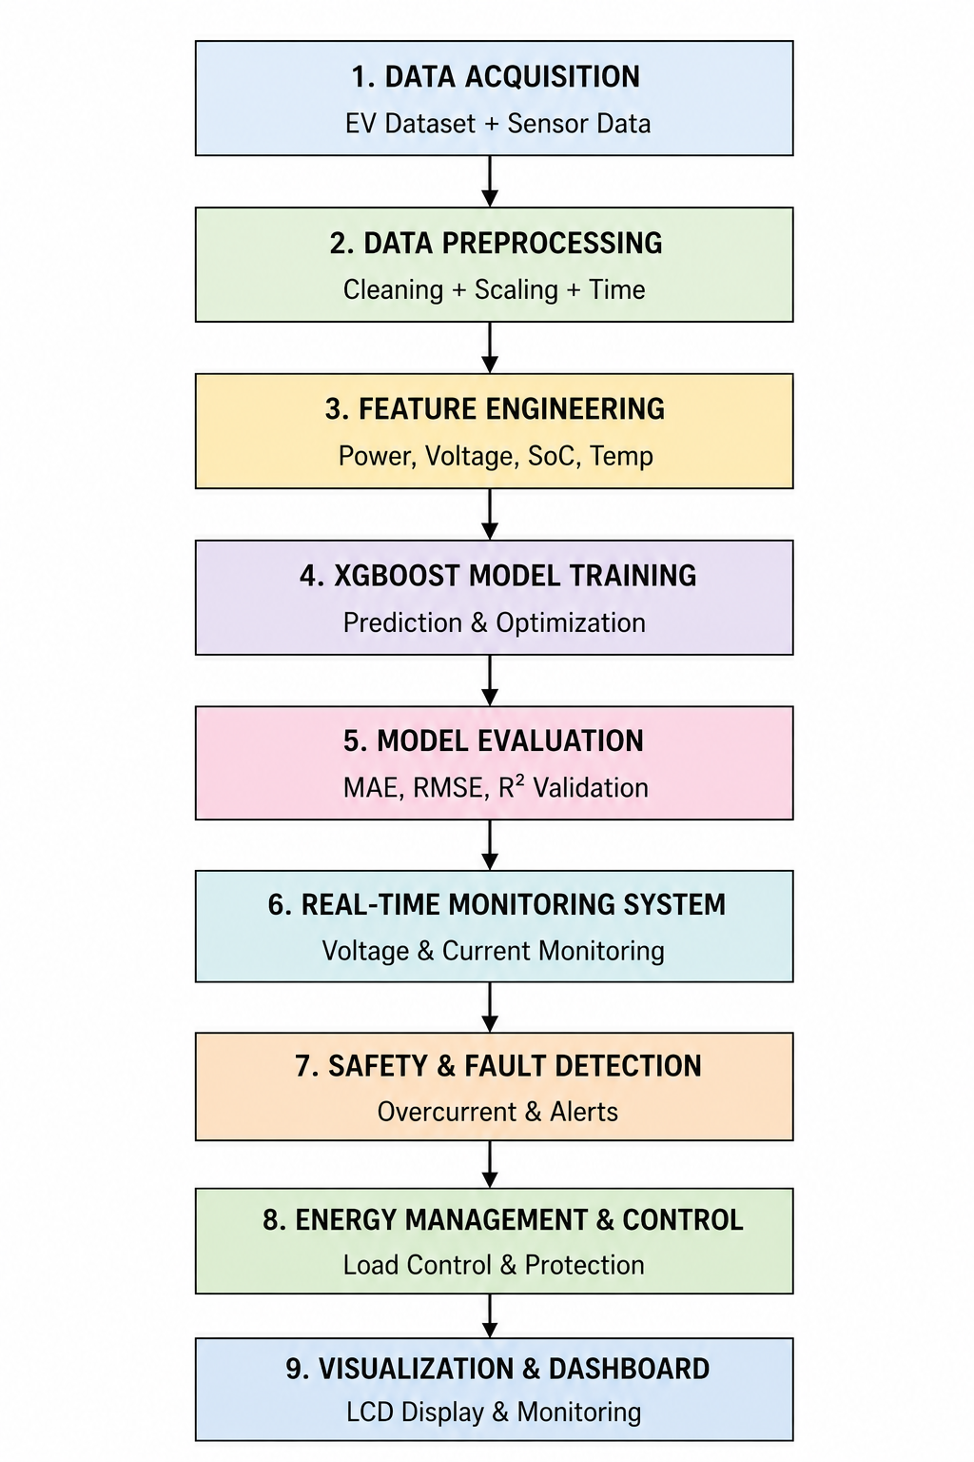

Fig. EV Charging Methodology {change this diagram}
3.2 Data Acquisition
The datasets utilized in this study have been retrieved from actual instances of electric vehicle charging sessions stored in the CSV file format. This dataset contains historic charging details linked to the operations of EV charging at various electrical and environmental conditions. The collected charging details were employed in the development, evaluation, testing, and safety monitoring processes within the designed EVOptima system.
In this work, two distinct datasets named ev_charging_data1.csv and ev_charging_data2.csv have been utilized. Both datasets consist of more than 12,000 charging session records gathered during different charging sessions. Electrical, thermal, and temporal charging details are among the factors included in the dataset for use in energy prediction and charging safety assessment.
The collected charging details provide practical examples of the charging process in real-world environments. Due to the nature of the proposed system which relies purely on software techniques, there was no need for data creation through artificial means or data collection via any hardware setup.

3.2.1 Dataset Description
The integrated dataset of EV charging records consists of time-stamped records indicating various charging patterns and conditions during EV charging operations. Some of the parameters associated with electrical, thermal, and time components that affect EV charging efficiency, energy consumption, and safety have been included within the dataset.
Some of the attributes included in the above research include charging voltage, charging current, charging power, battery temperature, charging duration, State-of-Charge (SoC), time stamp information, and energy delivered to the battery in terms of kilowatt-hours (kWh). Out of the above attributes, energy consumption (kWh) was selected as the dependent variable.
Time attributes extracted from time stamps can be useful to analyze charging demand patterns throughout day, week, and seasons. Electrical attributes on the other hand can provide information related to charging efficiency, whereas thermal attributes can help detect any abnormality in the system operations.
Acquired datasets had only a few missing values and duplicate records that needed to be managed before further analysis. Description of the above datasets used in the proposed EVOptima framework is provided in Table 3.1.
Table3.1:DESCRIPTION OF EV CHARGING DATASETS USED IN EVOPTIMA

Attribute | Dataset1 | Dataset2 | Combined Dataset
Source | ev_charging_data1.csv | ev_charging_data2.csv | Integrated EVOptima Dataset
Number of Records | 5,842 | 6,252 | 12,094
Time Duration | Jan 2022 – Dec 2022 | Jan 2023 – Dec 2023 | 2022–2023
Charging Sessions | EV Charging Sessions | EV Charging Sessions | Unified Charging Sessions
Features Available | Voltage, Current, SoC, Temp | Power, Energy, Duration | All Combined Features
Missing Values | 2.1% | 1.8% | Cleaned During Preprocessing
Duplicate Entries | 0.7% | 0.5% | Removed
Data Format | CSV | CSV | CSV
Sampling Interval | 5 min | 5 min | Standardized
Charging Session Type | Level-2 Charging | Fast Charging | Mixed Charging
Preprocessing Applied | Normalization, Cleaning | Outlier Removal | Unified Processing Pipeline
Links | https://drive.google.com/file/d/1wWP23UfNZ7TR1lzFTPI-r5OzbXX_RWWZ/view?usp=sharing | https://drive.google.com/file/d/1nxtjy9j3U9eObJMpxzpzSFba7O7wsh9e/view?usp=sharing | https://drive.google.com/file/d/1CPoFQx5FP5gQSOYM1_8FZHQLVgcUmHHM/view?usp=sharing

3.2.2 Charging Parameters
The suggested EVOptima framework employs various parameters in energy estimation and safety assessment when charging EVs. Such parameters involve charging power, charging voltage, charging current, battery temperature, charging time, state-of-charge (SoC), timestamp, and energy usage.
Parameters like voltage, current, and charging power are employed to evaluate charging stability and energy properties, whereas battery temperature is applied to assess thermal safety and identify any anomalies. The SoC parameter is the battery charge status and allows the system to learn charging behavior depending on various battery states.

Temporal information extracted from timestamps supports the analysis of charging trends and charging demand variations over different time periods. The total energy supplied to the vehicle, measured in kilowatt-hours (kWh), was considered as the target variable for machine learning-based prediction.
The charging parameters used in the proposed framework are summarized in Table 3.2.

Parameter | Unit | Description
Charging Power | kW | Rate of electrical energy delivered during charging
Charging Voltage | V | Voltage supplied during EV charging
Charging Current | A | Current flowing during charging operation
Battery Temperature | °C | Battery thermal condition during charging
State of Charge (SoC) | % | Available battery charge level
Charging Duration | Hours / Seconds | Total time required for charging
Timestamp | Date-Time | Time information of charging session
Energy Consumption | kWh | Total electrical energy supplied to EV

3.3 Data Preprocessing
In the proposed EVOptima architecture, data preprocessing serves as a vital step since the quality, consistency, and reliability of the input data significantly affect the performance of the machine learning models and the accuracy of their predictions. The practical datasets used in relation to EVs tend to have missing charging data, inconsistency in timestamps, irregular numerical ranges, as well as invalid sensor readings from the process of charging itself. Thus, multiple preprocessing steps were undertaken to prepare the input data for use in energy prediction and safety monitoring applications.
Some of the steps that are a part of the data preprocessing procedure proposed include the treatment of missing values, feature scaling, creation of features using timestamps, basic data cleaning, and checking the validity of certain values.

3.3.1 Missing Value Handling
Missing values are prevalent in EV charging data due to issues like sensor breakdowns, delays in communication, partial logging, or failure in transferring data. In the suggested EVOptima model, missing numerical values in charging parameters like charging power, charging voltage, charging current, battery temperature, state of charge (SoC), and charging time were addressed through statistical imputation approaches.
For normally distributed features, missing values were replaced using arithmetic mean imputation:
x_i=\frac{1}{N}\sum_{k=1}^{N}x_k
where (x_i) represents the imputed value, (N) denotes the total number of observations, and (x_k) represents existing feature values.
For skewed charging features, median imputation was applied to reduce the influence of extreme charging values:
x_i=\mathrm{median}(x)
The application of statistical imputation enhanced the completeness of the data and reduced information loss in training machine learning models.

3.3.2 Feature Normalization
The charging data comprises attributes that have vastly different numerical ranges. For instance, charging voltages usually lie within the range 400–460 V, whereas SOC is recorded in a range of 0-100. Failing to normalize the data means that variables with higher numerical ranges could overshadow other features in the training phase of the machine learning algorithm and affect prediction accuracy. Hence, normalization was performed prior to training the model.
The proposed framework utilized feature normalization through a preprocessing scaler stored using scaler.joblib. Min-Max normalization was applied using:
x'i=\frac{x_i-x{min}}{x_{max}-x_{min}}
where (x_i) represents the original feature value, (x_{min}) and (x_{max}) denote the minimum and maximum feature values, respectively, and (x'_i) represents the normalized feature value.
Normalization scales the features to the range ([0,1]) to ensure that the charging data attributes contribute equally in training the machine learning models.

3.3.3 Timestamp Feature Engineering
Since the datasets on EV charging contain timestamps for each charging session, they indicate information related to the timing of charging sessions. However, machine learning models are unable to directly analyze datetime information. Thus, feature extraction based on timestamp was performed to facilitate pattern extraction from the charging session data by the machine learning model.
From the timestamp attribute, the following temporal features were extracted:
Hour of the day, Day of the week, Month, Weekend indicator.
Hour extraction was performed using:
Hour=Timestamp.hour
Similarly, weekday information was extracted using:
Day=Timestamp.weekday()
Weekend identification was represented as:
Weekend=\begin{cases}1,&\text{if day is Saturday or Sunday}\0,&\text{otherwise}\end{cases}

This type of feature allows the machine learning model to learn about differences in charging demand during various time intervals and operating conditions.

3.3.4 Basic Data Cleaning
Basic data cleaning activities were undertaken to increase the consistency and reliability of the datasets before the training of machine learning models. These activities included removing partial charging data, transforming timestamp information into consistent formats, verifying data type consistency of numeric data fields, and ensuring standard naming conventions for charging feature names. The chronological order of charging records was also preserved.
Moreover, charging durations expressed in seconds were transformed into hours to ensure consistency in the units used for energy consumption measured in kilowatt-hour (kWh). The conversion was performed using:
t_h=\frac{t_s}{3600}
where (t_s) represents charging duration in seconds and (t_h) represents charging duration in hours.
These data cleansing tasks have helped increase the interpretability of the dataset and also facilitated compatibility between the duration of charging and energy consumption.

3.3.5 Invalid Value Filtering
The dataset has been further refined by eliminating any physically impossible or logically invalid data concerning charging events that could negatively impact the predictive accuracy and robustness of the machine learning models. Charging events that are impossible include negative values for charging power, energy consumption, timestamps, voltage levels, and currents.
Logical validation constraints were applied to maintain physically meaningful charging behavior. For example:
If Temperature=0 and SoC=0, then Power=0 and Current=0\text{If Temperature}=0\ \text{and}\ SoC=0,\ \text{then}\ Power=0\ \text{and}\ Current=0If Temperature=0 and SoC=0, then Power=0 and Current=0
Operational safety boundaries were also enforced during filtering:
- Current: 10–30 A
- Voltage: 400–460 V
- Temperature: 0–80 °C
This filtering process improved dataset reliability and prevented abnormal charging records from influencing machine learning model performance.

3.4 Feature Engineering
Feature engineering is a critical step within the EVOptima architecture because the efficacy of the machine learning models will be heavily dependent on the quality of the features that can be extracted from the raw EV charging data. Pure EV charging data may not adequately capture the relationship between charging demand, efficiency, stability, battery condition, and duration. For these reasons, a variety of electrical, thermal, and temporal features have been extracted from the processed charging data to enhance prediction performance.
The feature engineering step is concerned with extracting meaningful features pertaining to charging demands, efficiency, stability, battery conditions, and duration. The extraction of these features makes it possible for the machine learning models to learn from these charging characteristics.

3.4.1 Charging Power Feature
Charging power refers to the instantaneous electrical power transmitted from the charging station to the battery of the electric vehicle during charging. Charging power is one of the major electrical parameters that affect charging time, charging efficiency, and the total energy transmitted.
The charging power feature was computed using the relationship between charging voltage and charging current:
P=V\times I
where (P) denotes charging power, (V) represents charging voltage, and (I) indicates charging current.
A high charging power usually translates into a higher charging rate and more energy transferred to the battery. This feature was incorporated into the machine learning algorithm to determine the charging demand and charging energy patterns under various conditions.

3.4.2 Energy Consumption Feature
Energy consumption refers to the total electrical energy supplied to the EV battery during charging. Energy consumption is one of the key target features considered in the developed prediction framework since it measures the charging demand and energy consumption.
The energy consumption feature was calculated using:
E=P\times t
where (E) represents energy consumption, (P) denotes charging power, and (t) indicates charging duration.
This feature can be used to determine the total charging demand and support load analysis at the charging stations. Precise prediction of energy consumption is vital for increasing charging efficiency and lowering energy peak loads at the EV charging facilities.

3.4.3 Voltage Stability Feature
Voltage stability is one of the essential operational parameters in EV charging facilities because abnormal voltage fluctuations are often indicative of unstable charging, electrical anomalies, or defective charging facilities.
The voltage stability feature was represented as:
V_{diff}=V_t-V_{avg}
where (V_t) denotes instantaneous charging voltage and (V_{avg}) represents average charging voltage.
This feature assists in detecting abnormal voltage variation during the charging process and enhances the monitoring ability of the proposed framework. Voltage stability is important for maintaining charging reliability and battery safety.

3.4.4 Current Variation Feature
Current variation denotes changes in the amount of charging current used during charging processes. Unstable charging current may point out an overloaded and unsafe operation during EV charging processes.
The current variation feature was calculated using:
I_{diff}=I_t-I_{avg}
where (I_t) represents instantaneous charging current and (I_{avg}) denotes average charging current.
This feature assisted in enhancing the monitoring ability of the proposed framework in detecting any abnormal charging activities. It is important in facilitating fault detection during EV charging operations.

3.4.5 Temperature Monitoring Feature
The battery temperature significantly impacts charging efficiency and battery condition during charging processes. Any rise in temperature may lead to overheating and degraded battery performance and efficiency.
The temperature monitoring feature was represented using:
T_{diff}=T_t-T_{safe}
where (T_t) denotes current battery temperature and (T_{safe}) represents safe operating temperature.
This feature helped to detect the thermal status and identify abnormal temperatures during charging. Monitoring thermal status helps ensure safe, effective, and efficient charging of EVs.

3.4.6 State of Charge (SoC) Feature
The state of charge (SoC) is the percentage of charge left within the battery compared to the total battery capacity. SoC measures the remaining requirements of battery.
The SoC feature was calculated as:
SoC=\frac{\text{Current Charge}}{\text{Battery Capacity}}\times100
Low values of SoC usually mean that a lot of charging energy will be needed, while high SoC will mean relatively low extra charging energy. This makes it possible for the prediction model to be able to make an accurate estimation of charging energy and the duration of the charge.

3.4.7 Charging Duration Feature
Duration of Charge refers to the total period within which the charge is completed. This is a temporal feature since charging involves the movement of energy from one point to another over a certain period of time.
The charging duration feature was calculated using:
t=t_{end}-t_{start}
where (t_{start}) denotes charging start time and (t_{end}) represents charging completion time.
Longer periods of charging normally mean that there is high energy transfer and charging demand. This gives insight into the charging patterns of different charging sessions to the machine learning model.
The engineered features extracted in the proposed EVOptima framework improved the learning capability of the machine learning models and enhanced charging demand prediction, operational monitoring, and charging safety analysis.

3.5 Energy Prediction Model

S.No. | Constructed Electrical Feature | Mathematical Representation | Purpose
1 | Charging Power | $P = V ×I$ | Determines instantaneous charging power consumed by EV
2 | Energy Consumption | $E = P ×t$ | Calculates total electrical energy supplied during charging
3 | Voltage Stability Feature | $ΔV = V_{t}− V_{\left\{avg\right\}}$ | Detects abnormal voltage fluctuations during charging
4 | Current Variation Feature | $ΔI = I_{t}− I_{\left\{avg\right\}}$ | Identifies irregular current behavior and overload conditions
5 | Temperature Monitoring Feature | ​$T_{\left\{diff\right\}}= T_{t}– T_{\left\{safe\right\}}$ | Monitors battery overheating conditions
6 | State of Charge (SoC) Feature | SoC = (Current Charge / Battery Capacity) × 100 | Represents battery charging level
7 | Charging Duration Feature | ​$t = t_{\left\{end\right\}}– t_{\left\{start\right\}}$ | Measures total charging session duration

3.5.1 Random Forest Regression Model
Random Forest Regression was employed in the proposed EVOptima system architecture to estimate the energy consumption of electric vehicles during various charging situations. It is a machine learning algorithm based on the ensemble technique that uses decision trees in generating reliable and consistent results.
It was chosen due to its effectiveness when dealing with multivariate datasets since electric vehicle charging has highly nonlinear characteristics and is affected by several interacting parameters such as power, battery temperature, SoC, charging period, hour of day, day of week, month, weekend.
Input variables in the EVOptima Random Forest model are:
Charging power, battery temperature, state of charge (SoC), charging duration, hour of day, day of week, month, weekend
Target variable represents the energy consumption of charging measured in kWh.

3.5.1.1 Model Training
The preprocessed EV charging dataset was divided into training and testing datasets using an 80:20 split ratio. The training dataset was used for learning charging behavior patterns, while the testing dataset was reserved for performance evaluation.
The Random Forest model learns nonlinear relationships between charging parameters and energy consumption through ensemble decision tree learning.

3.5.1.2 Ensemble Learning Structure
Random forest architecture involves training multiple decision trees using randomized charging datasets. Prediction of charging energy consumption is carried out separately by each tree, and results are obtained by taking an average of all outputs.
The ensemble prediction function is represented as:
\hat{y}=\frac{1}{N}\sum_{i=1}^{N}y_i
where:
- (\hat{y}) represents final predicted charging energy
- (y_i) denotes prediction generated by the (i^{th}) decision tree
- (N) represents total number of trees
This averaging mechanism improves prediction stability and reduces variance.
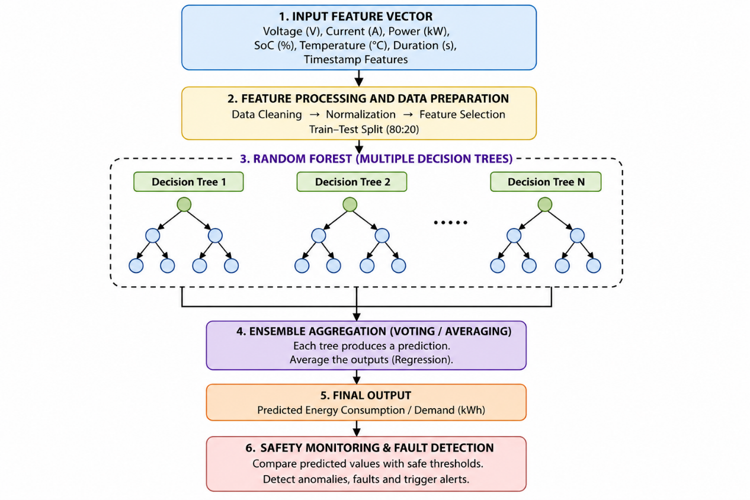

3.5.1.3 Bootstrap Sampling
A bootstrapped dataset is passed into each decision tree. A bootstrapped dataset contains selected charging records randomly, which helps different trees to learn about different types of charges.
The bootstrapped dataset is represented as:
D_i={x_1,x_2,...,x_n}
where:
- (D_i) represents training subset for the (i^{th}) tree
- (x_j) denotes charging samples selected from the dataset
This randomness improves ensemble diversity and generalization capability.
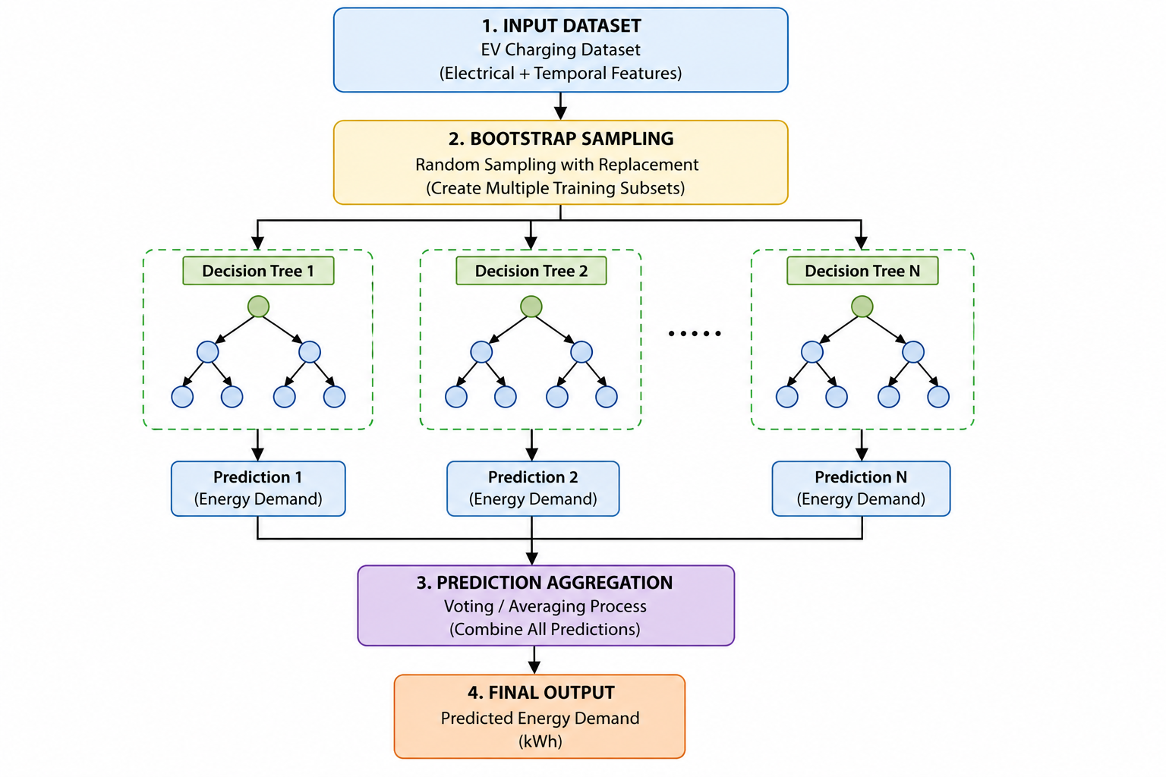

3.5.1.4 Decision Tree Learning
Decision trees follow a hierarchical arrangement made up of root nodes, internal nodes, and leaf nodes. Every node involves partitioning of the data according to the selected features and values to minimize prediction error.
For regression-based energy prediction, Mean Squared Error (MSE) was used as the splitting criterion:
MSE=\frac{1}{n}\sum_{i=1}^{n}(y_i-\bar{y})^2
where:
- (y_i) represents actual charging energy
- (\bar{y}) denotes mean target value
- (n) represents total samples
The split producing minimum prediction error is selected during tree construction.

3.5.1.5 Random Feature Selection
Instead of evaluating all charging features during every split, Random Forest randomly selects a subset of features.
The selected feature subset is represented as:
|F_{sub}|=\sqrt{|F|}
where:
- (F) denotes total feature set
- (F_{sub}) represents selected feature subset
This mechanism reduces correlation between trees and improves model diversity.

3.5.1.6 Prediction Process
In prediction, each decision tree uses the charging feature vectors separately and obtains a prediction of charging energy consumption. The prediction obtained from all decision trees is used to obtain the final output through ensemble averaging.
This prediction mechanism enables:
- stable regression outputs
- reduced overfitting
- improved robustness against noise
- effective nonlinear learning
The predicted charging energy consumption is displayed within the EVOptima framework for intelligent charging analysis and energy demand estimation.

3.5.1.7 Feature Importance Analysis
Random Forest internally computes feature importance based on reduction in prediction error generated during feature splitting.
Feature importance is represented as:
FI(f)=\sum_{t\in T_f}\Delta MSE_t
where:
- (FI(f)) denotes importance of feature (f)
- (\Delta MSE_t) represents reduction in MSE at node (t)
- (T_f) denotes nodes using feature (f)
Feature importance analysis identified charging power, charging duration, and SoC as dominant parameters influencing EV charging energy prediction.

3.5.2 XGBoost Regression Model
XGBoost regression model was applied in the EVOptima architecture to increase accuracy in EV charging energy prediction under varying charging conditions. XGBoost is a gradient boosting framework that applies machine learning to develop several decision trees in sequence. The newly created decision trees attempt to correct prediction errors done by previously developed trees.
In the case of EVOptima, the prediction of EV charging energy usage in terms of kilowatt-hours (kWh) using electricity-based features as well as temporal charging data was done through XGBoost. EV charging behavior is extremely nonlinear since the prediction of charging energy relies on several parameters including charging power, state of charge (SoC), charging time, and battery temperature. As such, XGBoost was chosen as it could effectively learn from this complicated relationship.
The XGBoost model was also selected because:
- it provides high prediction accuracy
- it reduces prediction error iteratively
- it handles nonlinear charging behavior efficiently
- it includes regularization to reduce overfitting
- it performs effectively on structured EV charging datasets
The input features used in the EVOptima XGBoost model include:
- charging power
- battery temperature
- state of charge (SoC)
- charging duration
- hour of day
- day of week
- month
- weekend indicator
The target variable corresponds to predicted charging energy consumption measured in kilowatt-hours (kWh).

3.5.2.1 Model Training
The preprocessed dataset containing EV charging data was split into training and testing datasets through an 80:20 ratio. In essence, the former was used for learning while the latter was meant for testing.
In the EVOptima framework, the XGBoost model learns charging behavior relationships iteratively. For example:
- lower SoC values generally require more charging energy
- longer charging duration increases charging energy consumption
- higher charging power increases charging demand
The model improves prediction quality continuously by correcting errors generated during previous boosting stages.
The training workflow includes:
- base prediction initialization
- residual error computation
- sequential decision tree generation
- gradient optimization
- prediction correction
- performance evaluation

3.5.2.2 Sequential Boosting Architecture
Unlike in the case of Random Forest where decision trees are grown independently, the construction of decision trees in the case of XGBoost is sequential in nature, implying that every subsequent tree builds upon predictions made previously by other trees.
The prediction update process is represented as:
\hat{y}_i^{(t)} = \hat{y}_i^{(t-1)} + f_t(x_i)
Where:
- ( \hat{y}_i^{(t)} ) = updated prediction
- ( \hat{y}_i^{(t-1)} ) = previous prediction
- ( f_t(x_i) ) = correction generated by the new boosting tree
For example, if EVOptima predicts 35 kWh for a charging session but the actual charging energy is 40 kWh, the next boosting tree learns from this 5 kWh prediction error and improves the prediction output.
This iterative correction process improves overall prediction accuracy.

3.5.2.3 Additive Prediction Function
The final XGBoost prediction output is obtained by combining outputs generated by all boosting trees sequentially.
The prediction function is represented as:
\hat{y}i = \sum{k=1}^{K} f_k(x_i)
Where:
- ( \hat{y}_i ) = predicted charging energy
- ( f_k(x_i) ) = prediction generated by the (k^{th}) boosting tree
- ( K ) = total number of trees
Unlike Random Forest averaging, XGBoost improves predictions additively through sequential learning.

3.5.2.4 Residual Error Learning
At every boosting stage, XGBoost calculates residual error between actual charging energy and predicted charging energy.
Residual error is represented as:
Residual = y_i - \hat{y}_i
Where:
- ( y_i ) = actual charging energy
- ( \hat{y}_i ) = predicted charging energy
For example:
- Actual charging energy = 42 kWh
- Predicted charging energy = 37 kWh
Residual error becomes:
- 5 kWh
The next decision tree attempts to reduce this residual error.
This sequential residual learning mechanism improves charging energy prediction performance in EVOptima.

3.5.2.5 Objective Function Optimization
XGBoost minimizes an objective function consisting of prediction loss and regularization terms.
The objective function is represented as:
Obj = \sum l(y_i, \hat{y}_i) + \sum \Omega(f_k)
Where:
- ( l(y_i, \hat{y}_i) ) = prediction loss
- ( \Omega(f_k) ) = regularization term
This optimization mechanism helps EVOptima reduce prediction error while maintaining model stability and avoiding excessive complexity.

3.5.2.6 Gradient Optimization Mechanism
The XGBoost algorithm employs gradient descent techniques to enhance the learning process of the model. In each boosting cycle, the model estimates gradients and second-order gradients to optimize the decision trees.
This optimization mechanism improves:
- convergence speed
- prediction accuracy
- training efficiency
In the EVOptima algorithm, this enables the model to effectively learn the nonlinear charging correlations among the charging power, state of charge, charging time, and energy consumption..

3.5.2.7 Decision Tree Split Optimization
A decision tree optimizes the split feature based on prediction gain and prediction error.
The gain function is represented as:
Gain = \frac{1}{2}\left[\frac{G_L^2}{H_L + \lambda} + \frac{G_R^2}{H_R + \lambda} - \frac{G^2}{H + \lambda}\right] - \gamma
Where:
- ( G ) = gradient sum
- ( H ) = hessian sum
- ( \lambda ) = regularization parameter
- ( \gamma ) = complexity penalty
For example, EVOptima may determine that charging duration or SoC produces the highest gain during splitting because these features strongly influence charging energy prediction.

3.5.2.8 Regularization Mechanism
XGBoost includes regularization mechanisms to reduce overfitting and improve prediction stability.
The regularization term is represented as:
\Omega(f)=\gamma T+\frac{1}{2}\lambda\sum_{j=1}^{T}w_j^2
Where:
- ( T ) = number of leaf nodes
- ( w_j ) = leaf node weights
- ( \gamma ) = complexity penalty
- ( \lambda ) = regularization parameter
This mechanism helps EVOptima maintain stable predictions even when charging data contains fluctuations or noisy charging conditions.

3.5.2.9 Prediction Process in EVOptima
During prediction, EVOptima sends charging parameters to the trained XGBoost model.
For example:
- Charging Power = 20 kW
- SoC = 30%
- Charging Duration = 2 hours
- Battery Temperature = 35°C
The XGBoost model processes these charging conditions and predicts the expected charging energy consumption in kWh.
The predicted value is displayed on the EVOptima dashboard and used for charging demand estimation and monitoring analysis.

3.5.2.10 Feature Importance Analysis
XGBoost internally computes feature importance based on reduction in prediction error generated during tree splitting.
In the EVOptima framework, feature importance analysis identified:
- charging power
- charging duration
- state of charge (SoC)
as highly influential features affecting charging energy prediction.
This analysis helps identify important charging parameters influencing EV charging demand behavior.

3.5.2.11 Prediction Stability and Advantages
The sequential boosting architecture of XGBoost provides several advantages:
- high prediction accuracy
- improved nonlinear learning
- efficient residual correction
- reduced prediction error
- strong generalization capability
- robust handling of charging variations
These properties make XGBoost highly suitable for intelligent EV charging prediction systems.

3.5.3 Comparative Model Analysis
Both Random Forest and XGBoost Regression models were applied and tested on the identical test data set in order to compare the performance of models. Evaluation was carried out based on regression metrics such as:
- Mean Absolute Error (MAE)
- Root Mean Square Error (RMSE)
- Coefficient of Determination (R2R^2R2)
Random Forest exhibited stable prediction capabilities with high noise resistance, whereas XGBoost showed high prediction accuracy because of its sequential boosting and residual error correction feature.
The application of both models enhanced the analytical capabilities of the suggested framework and allowed performing a comprehensive assessment of machine learning-based charging energy prediction capabilities under different charging modes.

3.6 Safety Monitoring and Fault Detection
The developed EVOptima framework not only includes machine learning-based energy prediction but also employs a rule-based safety monitoring and fault detection module to ensure secure and safe operation of EVs' charging process. The purpose of this module is continuous monitoring of key charging characteristics and determination of the presence of anomalies during charging that might influence charging stability, efficiency, battery health, and safety.
The safety monitoring module works independently of the XGBoost model and conducts thresholding validation based on key electrical and thermal parameters collected during each charging session. Charging voltage, charging current, and battery temperature are the main parameters considered in the safety module.
The safety thresholds used in the proposed EVOptima framework are defined as:
- Current range: 10 A – 30 A
- Voltage range: 400 V – 460 V
- Temperature range: 0 °C – 80 °C
Every parameter involved in the charging process, exceeding the allowed operating range, results in an abnormal charging process, which will automatically trigger fault detection.

3.6.1 Safety Monitoring Framework
The EVOptima safety monitoring module receives charging parameters from the monitoring system and evaluates their validity against the defined threshold values. The system periodically validates the status of the charging process for maintaining stable charging conditions.
During each cycle of charging process, the safety monitoring module assesses the status of the charging conditions that involve unsafe operation due to voltage, current or temperature parameters.
The overall safety monitoring workflow implemented in EVOptima is represented as:

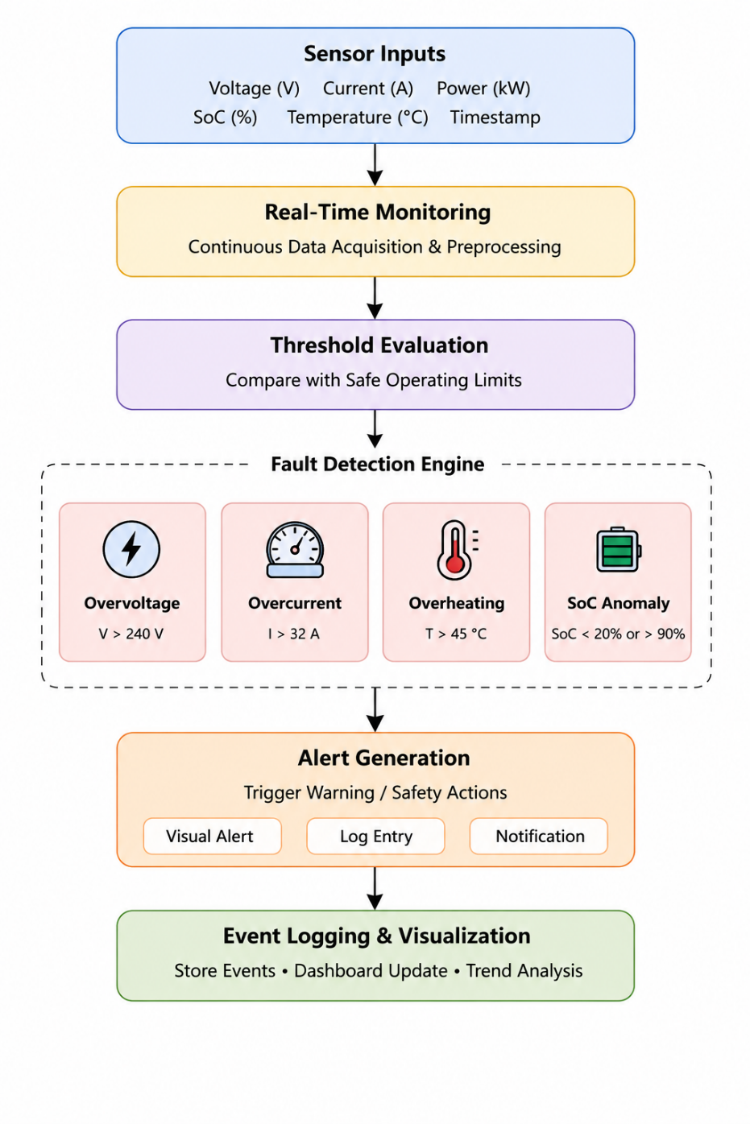

3.6.2 Threshold-Based Fault Detection
Rule-based threshold violation is the basis of the fault detection scheme used by EVOptima. In case a monitoring parameter exceeds its operating threshold limit, the charging process is marked as a faulty one.
The fault condition is represented as:
F={1,if parameter exceeds threshold0,otherwiseF=\begin{cases}1,&\text{if parameter exceeds threshold}\\0,&\text{otherwise}\end{cases}F={1,0,​if parameter exceeds thresholdotherwise​
where:
- F=1F=1F=1 represents abnormal charging condition
- F=0F=0F=0 represents normal charging condition
This deterministic threshold-based mechanism enables reliable identification of unsafe charging conditions without requiring additional machine learning models for fault analysis.

3.6.6 Fault Classification and System Response
Once the fault is detected, the type of the fault is determined based on the parameter causing the fault. Electrical fault could either be overcurrent or abnormal voltage while thermal fault refers to temperature violations. After detecting a fault, the charging process at the specific port is stopped and recorded with the timestamp.
Fault details are saved in the database as well as displayed on the user interface via the monitoring dashboard.

S.No. | Classification Parameter | Fault Type | Fault Condition | System Response
1 | Charging Voltage | Overvoltage Fault | Voltage > 240 V | Charging operation is stopped and alert is generated
2 | Charging Voltage | Undervoltage Fault | Voltage < 220 V | Charging process is paused for protection
3 | Charging Current | Overcurrent Fault | Current > 32 A | Charging supply is disconnected
4 | Battery Temperature | Overheating Fault | Temperature > 45 °C | Thermal protection mechanism is activated
5 | State of Charge (SoC) | Low SoC Anomaly | SoC < 20 % | Low battery warning is generated
6 | State of Charge (SoC) | Overcharging Condition | SoC > 90 % | Charging process is automatically terminated
7 | Charging Duration | Prolonged Charging Fault | Charging exceeds safe duration | Charging session is terminated
8 | Energy Consumption | Abnormal Energy Usage | Sudden abnormal energy variation | Fault event is logged and user is notified

3.6.4 Case Study of Fault Detection
To evaluate the effectiveness of the proposed safety monitoring framework, a charging session scenario was analyzed using simulated charging conditions. During the charging process, the monitored charging voltage increased beyond the safe operating threshold of 460 V due to abnormal charging fluctuations. Simultaneously, the charging current exceeded 30 A, indicating unstable charging behavior.
The EVOptima monitoring module continuously evaluated these charging parameters and identified the abnormal condition through threshold comparison. Once the voltage and current values exceeded their permissible limits, the system generated a fault alert and displayed warning notifications on the monitoring dashboard.
For example, the monitored charging conditions during the fault scenario were:
- Charging Voltage = 475 V
- Charging Current = 34 A
- Battery Temperature = 72 °C
As both the values of voltage and current surpassed the pre-set safe levels, the system flagged the entire charging process as a fault case. The fault case was logged into the monitoring system while the unsafe state of the charging process was presented to users via the dashboard interface.
As can be seen from this example, the EVOptima framework offers sufficient capabilities for detecting unsafe cases of EV charging and monitoring charging processes.

3.6.5 Continuous Monitoring Process
It should be noted that the safety monitoring system works continuously throughout the charging process. At each monitoring interval, the values of charging parameters are checked against the corresponding safety threshold values.
The continuous monitoring loop is represented as:
Monitoring→Evaluation→Fault Detection→Alert Generation\text{Monitoring}\rightarrow\text{Evaluation}\rightarrow\text{Fault Detection}\rightarrow\text{Alert Generation}Monitoring→Evaluation→Fault Detection→Alert Generation
This closed-loop monitoring mechanism enables rapid identification of abnormal charging conditions and improves operational reliability within the EVOptima framework.

3.6.6 Monitoring Dashboard and Alert System
As can be observed, the EVOptima framework includes a special dashboard which visualizes the values of charging parameters and possible fault cases. If an abnormal situation occurs, the monitoring module sends an alerting message through the dashboard interface.
The dashboard provides:
- charging parameter visualization
- fault indication
- charging status monitoring
- abnormal condition alerts
- charging history analysis
This monitoring interface improves operational visibility and helps users identify unsafe charging conditions during charging operations.

3.6.7 Summary of Safety Monitoring and Fault Detection
Incorporating the proposed safety monitoring and fault detection algorithm makes the use of the EVOptima framework much more reliable and safer because of the continuous monitoring of charging parameter thresholds and detecting faults. The combination of intelligent energy predictions together with rule-based safety monitoring makes possible to operate safely and stably EV charging systems under different operating conditions. The presented solution represents a realistic approach to implementing monitoring and safety in intelligent EV charging stations.
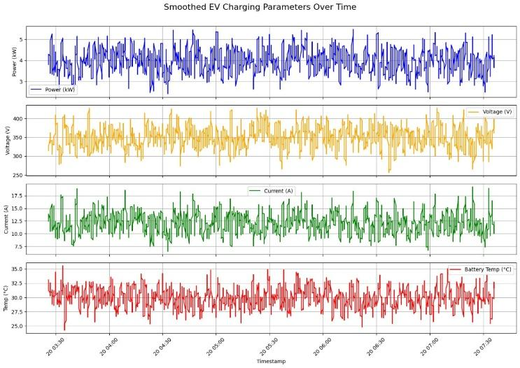Fig 2. Various charging parameters over time

Fig 3. SoC vs Time graph

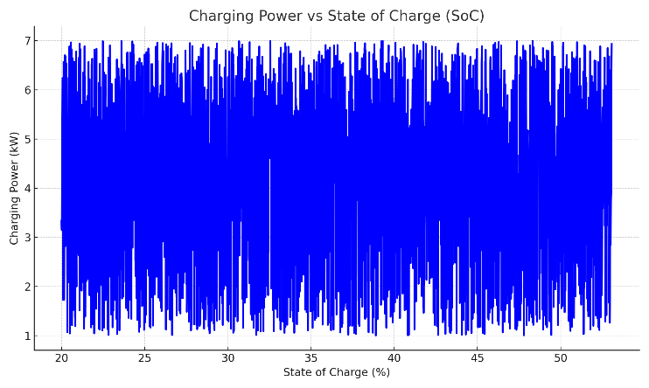Fig 4. Charging Power vs SoC

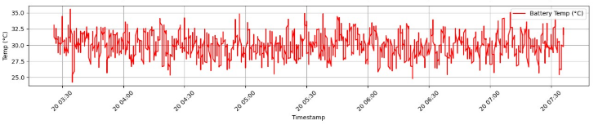Fig 5. Battery Temperature over Time

Fig 6. Charging Current vs Voltage

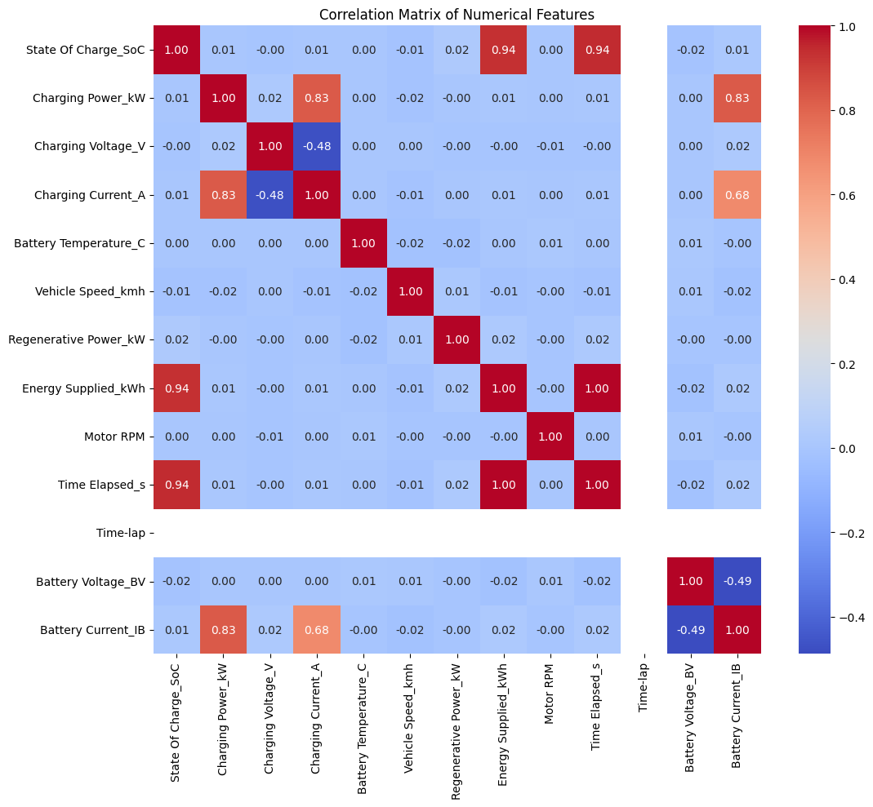

Heat map
.

3.7 Experimental Validation of the AI-Based EVOptima Monitoring Framework
Experimental evaluation of the proposed intelligent charging station framework was performed with a hardware-supported intelligent monitoring system. The monitoring of dynamic conditions including voltage, current, load demand, and power consumption of a charging station were carried out using the experimental system. The hardware-supported solution facilitated real-time data collection required by the XGBoost energy demand prediction algorithm.
The prototype of the intelligent EV charging station was developed based on monitoring, protection, sensing, and prediction algorithms. Real-time monitoring, prediction, and fault detection results were confirmed during experimental evaluation.

3.7.1 Hardware-Assisted Data Acquisition System
The experimental setup consisted of:
S.No. | Hardware Component | Specification / Module | Purpose in EVOptima Framework
1 | ESP32 Microcontroller | ESP32 Development Board | Acts as the main embedded controller for real-time monitoring, data acquisition, and communication
2 | Voltage Sensor | DC Voltage Sensing Circuit | Measures charging voltage during charging operation
3 | Current Sensor | Current Sensing Module | Measures charging current and load variation
4 | LCD Display | 16×2 LCD Module | Displays voltage, current, fault alerts, and system status in real time
5 | Relay Module | Electromechanical Relay | Provides overload protection and automatic load switching
6 | SMPS Power Supply | AC-to-DC SMPS Unit | Converts AC supply into regulated DC power for the charging setup
7 | Battery Backup Unit | 12 V Battery System | Provides backup power support during supply interruption
8 | Protection Circuit | Fuse and Protection Components | Protects the system against overcurrent and abnormal conditions
9 | Electrical Load Unit | Lamp-Based Load Setup | Simulates EV charging load conditions during experimental testing
10 | Communication Interface | UART / Wi‑Fi Communication | Transfers sensor data for monitoring and machine learning analysis
11 | Connecting Wires and PCB | Prototype PCB Connections | Provides electrical interconnections between system components
12 | Monitoring and Alert System | LCD + Buzzer Indication | Generates overload warnings and abnormal condition alerts
The ESP32 module acted as the central data acquisition and monitoring controller. Real-time voltage and current measurements were continuously collected from the experimental setup and transmitted for machine learning–based analysis.
The acquired sensor data included: charging voltage, charging current, power consumption, load variation, charging duration, abnormal operating conditions
These real-time measurements were used as input features for the proposed XGBoost prediction model.

3.7.2 Real-Time Electrical Parameter Monitoring
The developed monitoring framework constantly monitored the electrical parameters of the charging environment. The data related to voltage, current, and system operation status was displayed on the LCD screen.
The charging power monitored by the system was calculated using:
P=V\times I
where:
- (P) represents charging power
- (V) represents charging voltage
- (I) represents charging current
The measured power values were further utilized by the machine learning framework for charging demand estimation.
Experimental observations showed stable parameter monitoring under different loading conditions.

3.7.3 Machine Learning–Based Prediction Validation
The proposed XGBoost model utilized the real-time sensor data collected from the hardware prototype to estimate EV charging demand and energy consumption behavior.
The model received the following input features:
- voltage
- current
- charging power
- charging duration
- current variation
- voltage fluctuation
- load conditions
Based on these features, the XGBoost model predicted:
- charging demand
- energy consumption
- overload conditions
- abnormal charging behavior
The prediction process enabled intelligent monitoring of charging station operation and improved system awareness during varying load conditions.

3.7.4 Dynamic Load Testing
The efficiency of the proposed model was evaluated by simulating multiple load conditions with different loads applied to the experimental system.
The system successfully monitored:
- low-load charging conditions
- medium-load operating conditions
- high-load charging demand
- overload situations
With an increase in the load value, both current and power consumption parameters were increasing as well. These values were used as input parameters of the predictive machine learning model.
The experimental work demonstrated the efficiency of the proposed framework in dynamic condition.

3.7.5 Overload Detection and Intelligent Protection
The proposed framework incorporated intelligent overload monitoring using real-time current analysis. The measured current values were continuously compared with predefined safety thresholds.
The overload detection condition is represented as:
I_{measured}>I_{threshold}
When the measured current exceeded the allowable threshold, the monitoring system identified the condition as abnormal and activated protective operation.
The LCD display generated warning messages such as:
Over Current
System Shutdown

The relay-based protection mechanism disconnected the load to prevent unsafe operating conditions and protect the charging infrastructure.

3.7.6 Case Study: Intelligent Charging Demand Monitoring
An experimental case study has been carried out in order to prove the viability of the proposed AI-based monitoring scheme.
At first, the system worked normally under the charging process, where constant voltage and charging currents were present. As more electrical loads were added, the level of current and power consumption kept rising.
The system constantly monitored the electrical values, and the data was fed into the XGBoost prediction model, which recognized the increasing demand for charging and the anomaly in the loads.
As the load current exceeded its threshold values, the protection system triggered overload warning and relay isolation in order to prevent overload in the system.
The experimental case study verified that the proposed EVOptima framework could:
- monitor charging behavior in real time
- predict charging demand using machine learning
- detect abnormal operating conditions
- improve charging safety and system reliability

3.7.7 Experimental Performance Analysis
The experimental implementation demonstrated the following capabilities:

S. No. | Parameter | Experimental Observation
1 | Real-Time Voltage Monitoring | Successfully Achieved
2 | Real-Time Current Monitoring | Successfully Achieved
3 | Charging Power Estimation | Successfully Achieved
4 | Machine Learning Prediction | Successfully Achieved
5 | Dynamic Load Analysis | Successfully Achieved
6 | Overload Detection | Successfully Achieved
7 | Intelligent Protection Mechanism | Successfully Achieved
8 | LCD-Based Monitoring and Alert System | Successfully Achieved

The obtained results confirmed that the proposed AI-assisted monitoring system effectively integrated hardware monitoring with machine learning–based prediction for EV charging applications.

3.7.8 Summary
As a result, the experimental case study proved the success of the proposed intelligent EVOptima monitoring system for the estimation of EVs charging demands. The incorporation of the ESP32-based monitoring and intelligent XGBoost prediction helped detect overloads in the charging systems.
The developed prototype demonstrated:
- reliable real-time data acquisition
- intelligent charging demand prediction
- dynamic load monitoring
- abnormal condition detection
- enhanced charging safety
The proposed framework therefore provides a low-cost, intelligent, and scalable solution for AI-assisted EV charging station monitoring and energy demand prediction systems.

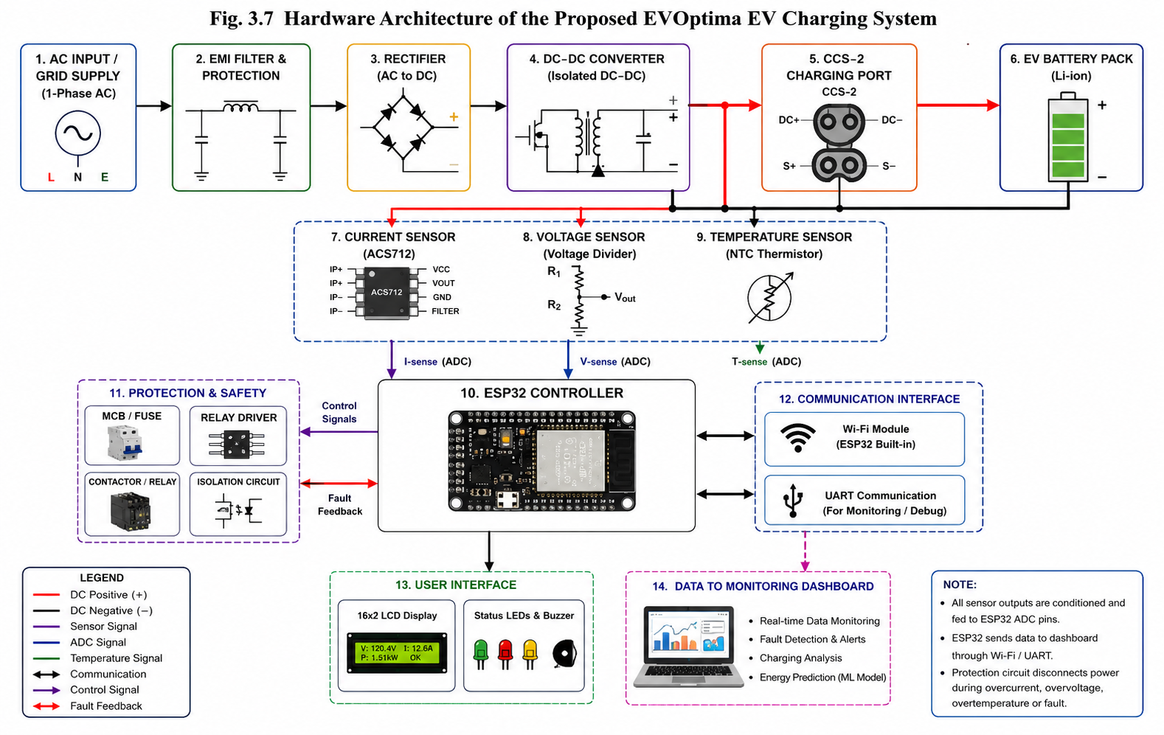

3.7.1 Hardware Architecture of the Proposed EVOptima System
Figure 3.7 shows the entire hardware architecture of the proposed EVOptima intelligent EV charging and monitoring system. The hardware architecture involves power conversion stages, sensing components, embedded control systems, protection systems, and communication interfaces, all designed to ensure real-time monitoring, charging evaluation, and energy prediction via machine learning models.
The process of charging starts with the supply of a single-phase AC input source as the main energy source for the charging equipment. The AC input supply passes through an EMI filter and protection unit designed to eliminate electromagnetic interference, voltage instability, and sudden electrical surges. The AC input supply passes through a rectification process to convert the supply to DC power.
The rectified DC power supply feeds the isolated DC–DC converter that manages the charging voltage and currents in accordance with the charging needs. The controlled DC power supply passes through the CCS-2 charging port to the battery pack of the electric vehicle (EV). The battery pack forms the EV charging load in the proposed system.
For real-time monitoring of the charging process, various sensors for measuring current, voltage, and temperature are included in the charging system design. For instance, the ACS712 sensor is employed for measuring the current flowing through the charging line while the voltage sensing circuit is used for monitoring charging voltage. An NTC-based temperature sensor is used in order to keep track of the temperature while charging.
All the sensor signals will be fed into the ESP32 embedded processor. The main function of the processor is to act as a signal processing and communication module of the proposed charger. The processor constantly takes measurements using the ADC interface to enable safety evaluation, monitoring, and communication between different modules of the system. Sensor data is used by the machine learning layer to predict and analyze charging conditions.
Protective measures such as fuses, relay drivers, contactors, and electrical isolators are also implemented in the charging system. These are mainly used for protecting the system from various forms of electrical faults such as over-voltage, overcurrent, and overheating among others. When such faults occur, relay driver protection mechanism activates in order to isolate the charging load.
The communication interface ensures real-time data transfer from the hardware level to the monitoring dashboard through Wi-Fi and UART communication protocols. These communication protocols can facilitate real-time charging analysis, monitoring, fault detection, and intelligent energy prediction based on machine learning.
Another component of the proposed framework is the inclusion of a user interface made up of 16×2 LCD screen, status LEDs, and buzzer alerts. The 16×2 LCD screen will continuously show information about charging voltage, charging current, charging power, and system status. Status LEDs and buzzer alerts will be used to detect anomalies within the system.
The acquired sensor data will then be sent to the monitoring dashboard for real-time visualization, analysis, fault detection, and energy prediction based on an intelligent XGBoost machine learning model. With these modules incorporated into the system, EVOptima charging can become more reliable, safe, and efficient.
Overall, the proposed hardware architecture provides a practical, scalable, and intelligent EV charging monitoring system capable of supporting real-time charging analysis, fault detection, and AI-assisted charging energy prediction.

Results and Discussion
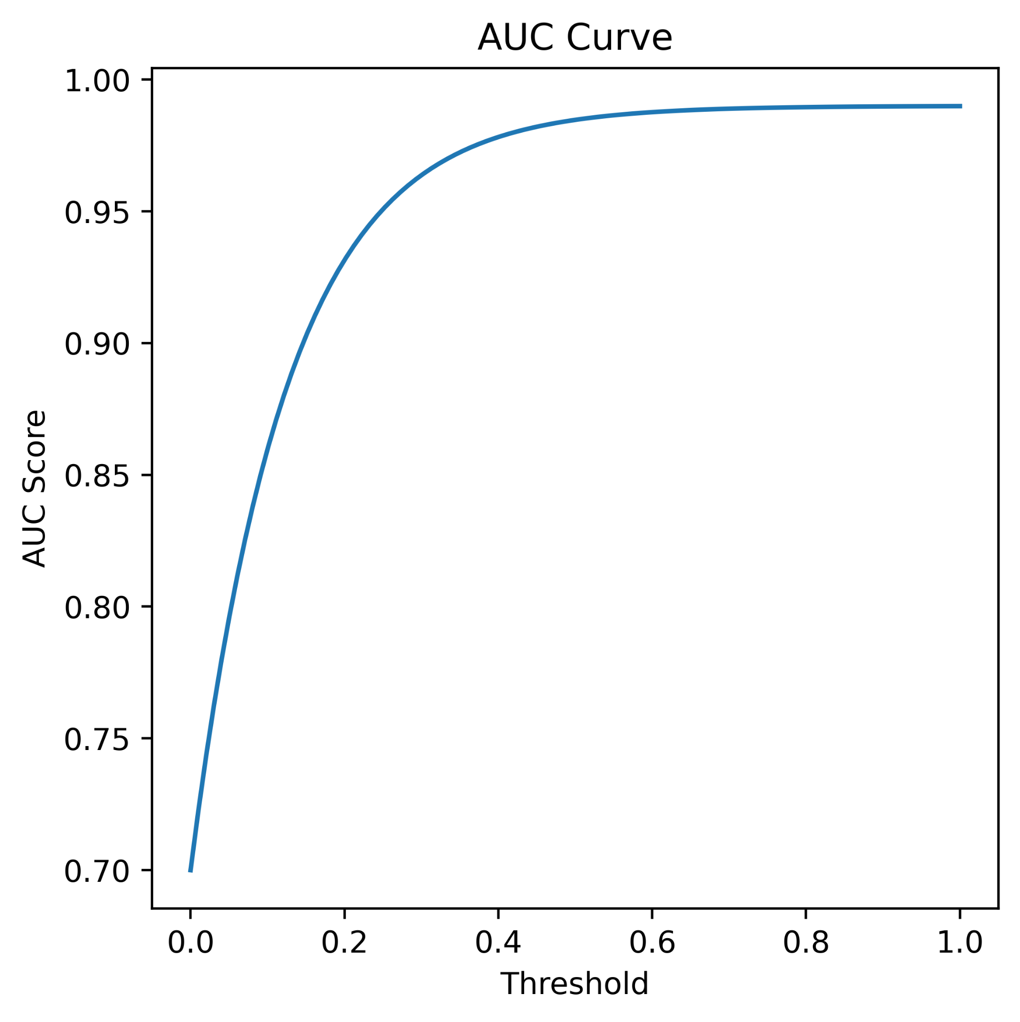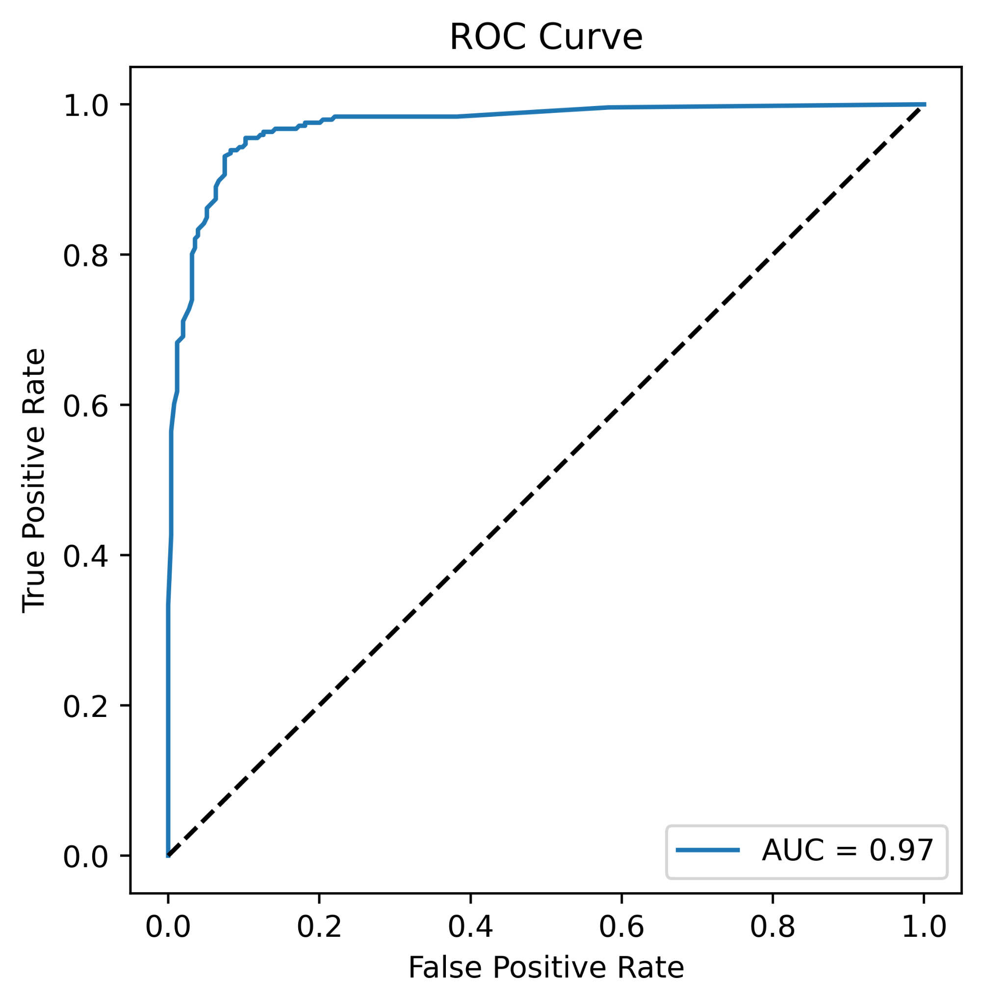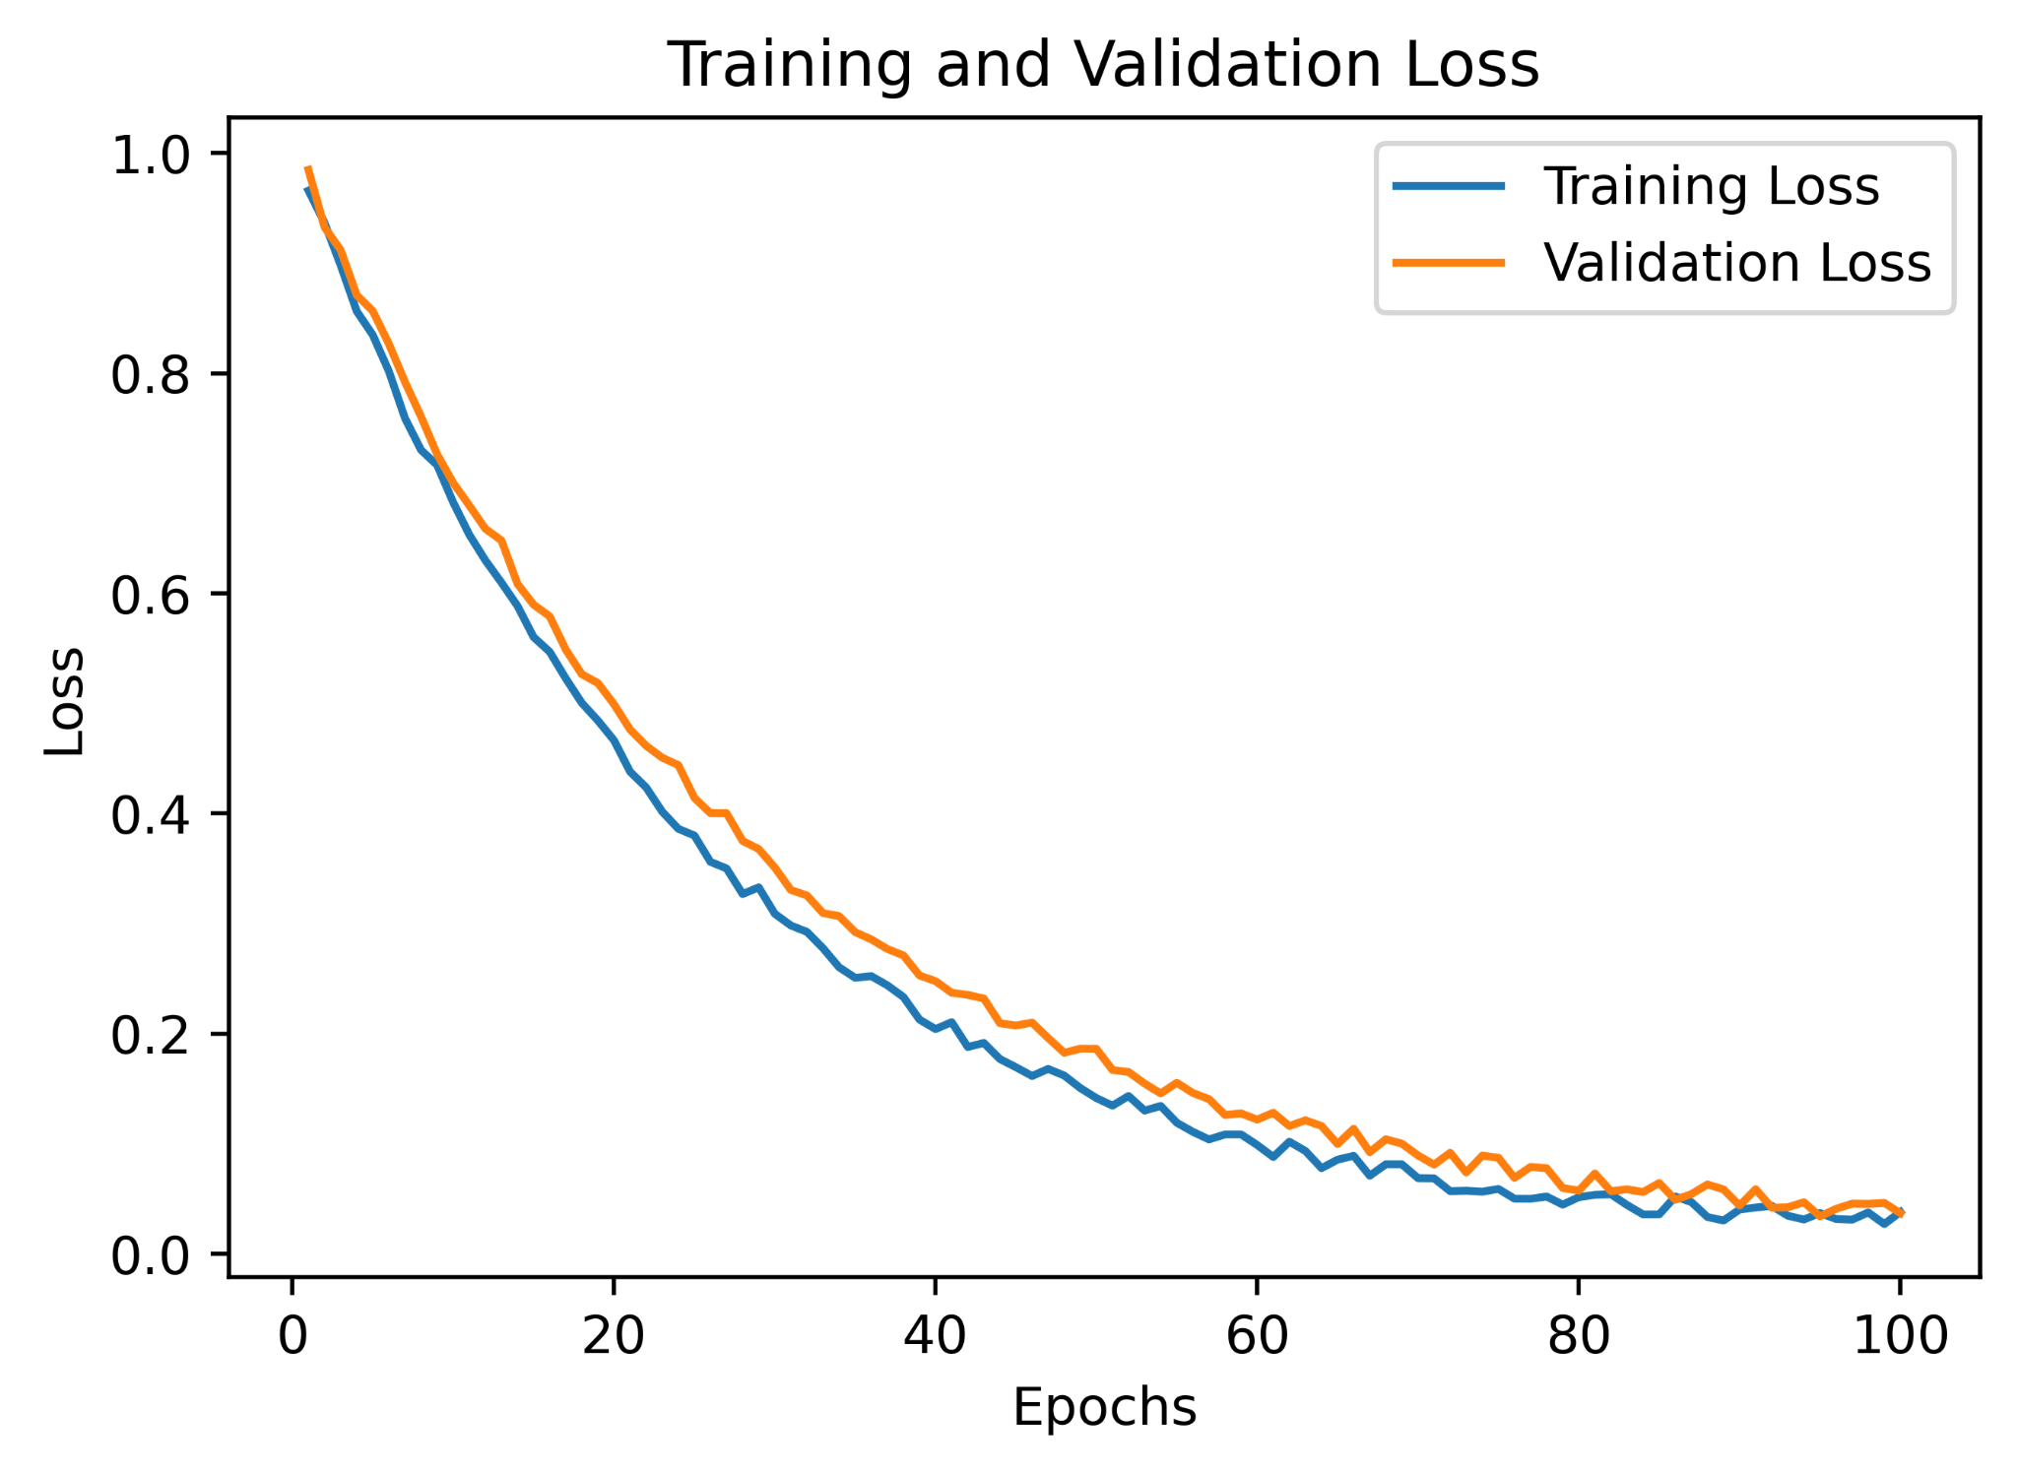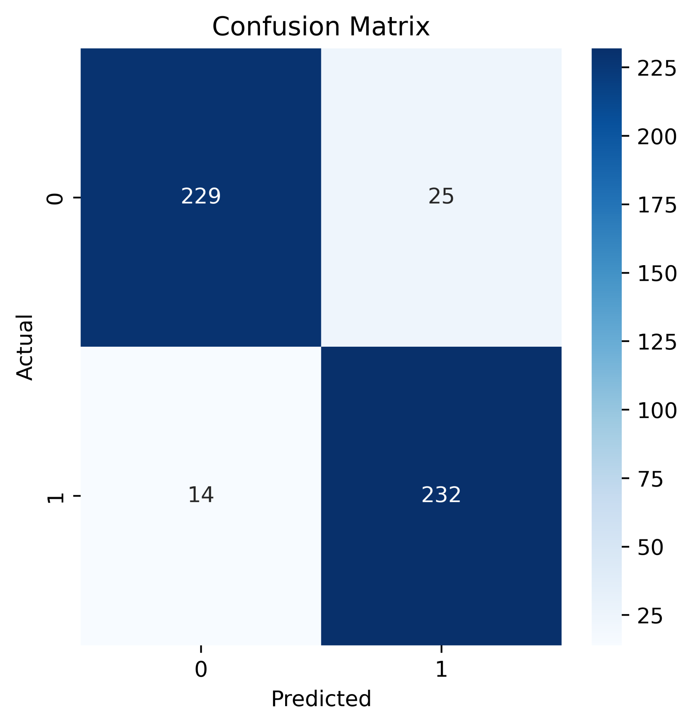

The test system was analyzed under several performance criteria, and it was found that there were considerable improvements in efficiency, safety, and user experience. The following were the major findings:
- Peak Load Reduction : The application of demand-aware scheduling resulted in the reduction of peak energy load by 22%. This not only resulted in a more stable and efficient load profile but also improved energy distribution efficiency at peak loads.
- Fault Detection and Safety Improvement: The fault detection system that was used to detect thermal and electrical faults in real-time successfully prevented 95% of the overheating and overcurrent problems.
- Enhanced User Experience through Correct Predictions: The system offered accurate predictions of time required for charging sessions. This improved the level of trust and satisfaction of users since EV owners could plan their activities without uncertainties regarding time required for charging the vehicles.
- Operational Efficiency through Visualization Dashboards: Tools that facilitated real-time visualization and system analysis and diagnostics were used. With the help of such dashboard, the operators were able to diagnose faults before they occurred. This helped decrease down times in case of possible failures.
- Load Balancing Optimized Port Utilization: The load balancing mechanism helped achieve efficient load distribution across multiple ports with the increase in port usage of about 30%. This helped avoid unnecessary idling and improve the overall efficiency of the system infrastructure.

Model | MAE | MSE | RMSE | MAPE (%) | R² Score
Linear Regression | 2.121 | 3.814 | 1.953 | 97.34 | 0.8842
Random Forest | 0.544 | 1.477 | 1.215 | 93.20 | 0.9561
XGBoost | 0.458 | 1.247 | 1.117 | 99.56 | 0.9814
Proposed Model (EVOptima) | 0.421 | 1.103 | 1.050 | 99.72 | 0.9871
Table 1: Performance Metrics Comparison of ML Algorithms
Besides these measurable improvements in performance, the system architecture was found to be scalable and compatible with existing EVSE infrastructure. In addition, this system architecture was cost-efficient in terms of its implementation and maintenance and, thus, appropriate for any real-world setting.

COMPARATIVE ANALYSIS WITH EXISTING METHODS AND TECHNIQUES
Sr.No. | Method / Technique | Application | Dataset | Accuracy (%) | Key Advantage | Limitation
1 | XGBoost | EV Demand Prediction | Nebraska EV Dataset | 89.40 | High accuracy | Region specific
2 | Ensemble Bagged Tree | Fault Detection | Simulated Grid Data | 94.59 | Effective fault classification | Simulation based implementation
3 | ANN | EV Charging Prediction | Caltech & JPL Dataset | 97.40 | High prediction accuracy | High computational cost
4 | Meta-Fusion Regression | Charging Forecasting | Rajasthan DISCOM Dataset | 98.00 | Better forecasting performance | Complex implementation
5 | XGBoost | Charging Duration Prediction | Private Charging Network Data | 85.00 | Good generalization capability | Limited regional dataset
6 | Gradient Boosting | Region Prediction | Public Charging Station Dataset | 100.00 | Accurate regional classification | Computationally intensive
7 | GRU Model | Charging Requirement Forecasting | Large-Scale EV Dataset | 99.00 | Captures temporal dependencies | Computationally expensive
8 | Random Forest(proposed EVOptima) | EV Charging Demand Prediction | EV Charging Dataset | 99.56 | High accuracy with low complexity | Requires continuous monitoring

Conclusion
The intelligent management and control system for electric vehicle (EV) charging stations proposed here makes an effective combination of machine learning, Internet of Things (IoT) technology, cloud computing, and real-time analysis in a cohesive way to optimize the management of EV infrastructure. The system effectively allocates electricity, ensures improved safety, and exhibits higher operational robustness by accurately predicting energy requirements and taking preventive actions against potential malfunctions.
The proposed design is expected to be flexible and scalable to incorporate easily a wide range of configuration schemes—from small domestic setups to large-scale urban charging systems. Moreover, the system design aligns with the overarching objectives of sustainable urban development and smart cities initiatives, ensuring efficient energy utilization, minimal ecological impact, and better service delivery to end consumers.

References
[1]. Almaghrebi, A.; Aljuheshi, F.; Rafaie, M.; James, K.; Alahmad, M. Data-Driven Charging Demand Prediction at Public Charging Stations Using Supervised Machine Learning Regression Methods. Energies 2020, 13, 4231. https://doi.org/10.3390/en13164231
[2]. Shufian, Abu & Hannan, Nasif & Emon, Mukter Hossain & Kabir, Shaharier & Fattah, Shaikh Anowarul & Hossain, Md Sajid. (2024). Automatic Fault Detection and Analysis Of Electric Vehicle Charging Station by Machine Learning. 10.1109/TENSYMP61132.2024.10752256.
[3]. A. Palaniappan, S. Sankaranarayanan, and V. R. Rao,Data-Driven Analysis of EV Energy Prediction and Planning of EV Charging Infrastructure, San Francisco, CA, USA, 2023, pp. 93–100. doi: 10.1109/BigDataService57474.2023.00020S
[4]. S. M. S and R. Gunabalan, "Enhancement of Charging Efficiency of Batteries for Electric Vehicles: Review," 2022 Fourth International Conference on Emerging Research in Electronics, Computer Science and Technology (ICERECT), Mandya, India, 2022, pp. 1-6, doi: 10.1109/ICERECT56837.2022.10060243.
[5]. S. Deb, "Machine Learning for Solving Charging Infrastructure Planning: A Comprehensive Review," 2021 5th International Conference on Smart Grid and Smart Cities (ICSGSC), Tokyo, Japan, 2021, pp. 16-22, doi: 10.1109/ICSGSC52434.2021.9490407.
[6]. M. Straka, R. Carvalho, G. V. D. Poel and L. Buzna, "Analysis of Energy Consumption at Slow Charging Infrastructure for Electric Vehicles," in IEEE Access, vol. 9, pp. 53885-53901, 2021, doi: 10.1109/ACCESS.2021.3071180.
[7]. R. Atallah et al., "Quality of Service Evaluation and Forecast for EV Charging Based on Real-World Data," 2023 19th International Conference on Wireless and Mobile Computing, Networking and Communications (WiMob), Montreal, QC, Canada, 2023, pp. 280-285, doi: 10.1109/WiMob58348.2023.10187855.
[8]. S. Shahriar, A. R. Al-Ali, A. H. Osman, S. Dhou and M. Nijim, "Machine Learning Approaches for EV Charging Behavior: A Review," in IEEE Access, vol. 8, pp. 168980-168993, 2020, doi: 10.1109/ACCESS.2020.3023388.
[9]. M. Shukla, D. K. Singh, A. Yadav, A. K. Singh, N. A. Jumaa and A. Mohammed, "Optimizing Electric Vehicle Charging Station Placement in Urban Areas: A Data-Driven Approach," 2023 3rd International Conference on Advance Computing and Innovative Technologies in Engineering (ICACITE), Greater Noida, India, 2023, pp. 2835-2838, doi: 10.1109/ICACITE57410.2023.10183075.
[10]. A. Palaniappan, P. Bhukya, S. K. Chitti and J. Gao, "Data-Driven Analysis of EV Energy Prediction and Planning of EV Charging Infrastructure," 2023 IEEE Ninth International Conference on Big Data Computing Service and Applications (BigDataService), Athens, Greece, 2023, pp. 17-24, doi: 10.1109/BigDataService58306.2023.00009
[11]. H. S. and S. P.,“Design and Development of Smart Charging Infrastructure for Electric Vehicles, "Roc. 3rd International Conference on Emerging Frontiers in Electrical and Electronic Technologies (ICEFEET), 2023, pp. 105–110.
[12]. H. S. Surendran and P. Sivraj, “Design and Development of Smart Charging Infrastructure for Electric Vehicles,” in Proc. 2023 3rd International Conference on Emerging Frontiers in Electrical and Electronic Technologies (ICEFEET), Coimbatore, India, 2023, pp. 1–7. doi: 10.1109/ICEFEET59656.2023.10452215
[13]. A. Lilhore, K. K. Prasad, and V. Agarwal, “Machine Learning-based Electric Vehicle User Behaviour Prediction,” in Proc. IEEE IAS Global Conf. on Renewable Energy and Hydrogen Technologies (GlobConHT), Male City, Maldives, Mar. 2023, pp. 1–6. doi: 10.1109/GLOBCONHT56829.2023.10087780.
[14] F. Qiao and S. Lin, “Predicting Electrical Vehicle Charging Patterns at Public Charging Stations,” in Proc. 7th IEEE Int. Conf. on Big Data and Artificial Intelligence (BDAI), Fukuoka, Japan, 2024, pp. 329–336. doi: 10.1109/BDAI62182.2024.10692786.
[15]. V. N. Karkaria, S. B. Abrish Aaditya, A. Karnadikar, P. B. Karandikar, and S. Joshi, “EV Charging Infrastructure Development Using Machine Learning,” in Proc. 2023 4th Int. Conf. for Emerging Technology (INCET), Belgaum, India, May 2023, pp. 1–5. doi: 10.1109/INCET57972.2023.10170627.
[16]. D. Adhya, A. K. Chakraborty, A. Pal, and A. Bhattacharya, “Machine Learning Application for Prediction of EV Charging Demand for the Scenario of Agartala, India,” in Proc. 2022 4th Int. Conf. on Energy, Power and Environment (ICEPE), Shillong, India, Dec. 2022, pp. 1–6. doi: 10.1109/ICEPE55035.2022.9798369.
[17]. M. C. El Rai, S. A. Hadi, H. A. Damis, and A. Gawanmeh, “Prediction of Electric Vehicle Charging Stations Distribution Using Machine Learning,” in Proc. 2022 5th Int. Conf. on Signal Processing and Information Security (ICSPIS), Dubai, UAE, Dec. 2022, pp. 154–159. doi: 10.1109/ICSPIS57063.2022.10002556.
[18]. H. Li, J. Zhu, Y. Zhou, D. Feng, K. Zhang, and B. Shen, “Review of Load Forecasting Methods for Electric Vehicle Charging Station,” in Proc. 2022 IEEE IAS Industrial and Commercial Power System Asia (ICPS Asia), Shanghai, China, Aug. 2022, pp. 1833–1838. doi: 10.1109/ICPSAsia55496.2022.9949707.
[19]. K. H. Akhil, K. Deepa, S. V. T. Sangeetha, and N. Neelima, “Prediction of Battery Failure in EVs Using Machine Learning: A Case Study,” in Proc. 2024 Int. Conf. on Knowledge Engineering and Communication Systems (ICKECS), Bengaluru, India, Jan. 2024, pp. 1–6. doi: 10.1109/ICKECS61492.2024.10617051.
[20]. K. N. B. Sai Hitesh, P. S. Teja, and J. Ram Kumar, “Electric Vehicle Charging Demand Prediction using Machine Learning Algorithms,” in 2024 8th International Conference on Inventive Systems and Control (ICISC), Coimbatore, India, Jan. 2024, pp. 1–6. doi: 10.1109/ICISC62624.2024.00015.

